Straight-Line Path
# Source: AI Source: Provided by: [Data Path: Persons Table -> ID Column: 1, Name_En Column: Motasem Essam] -> From: [ChatGPT] on [7/25/2026]
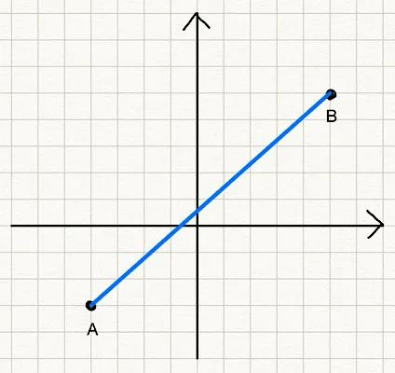
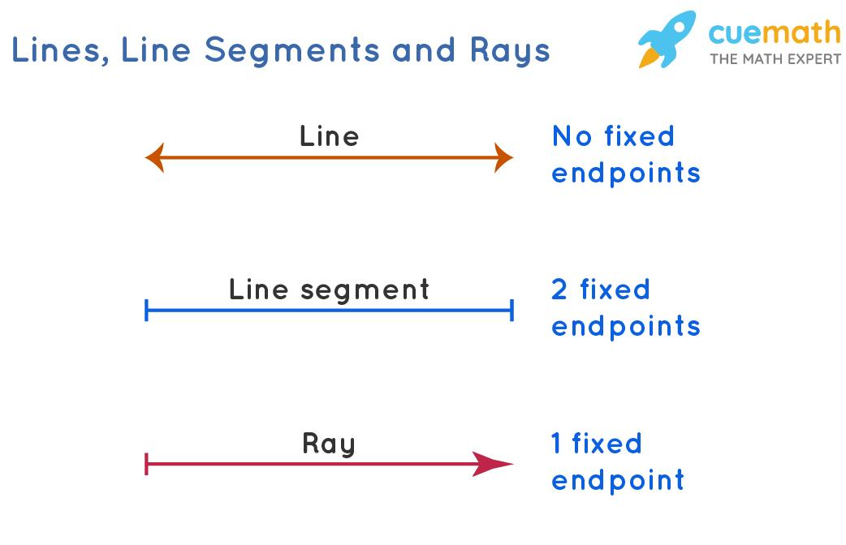
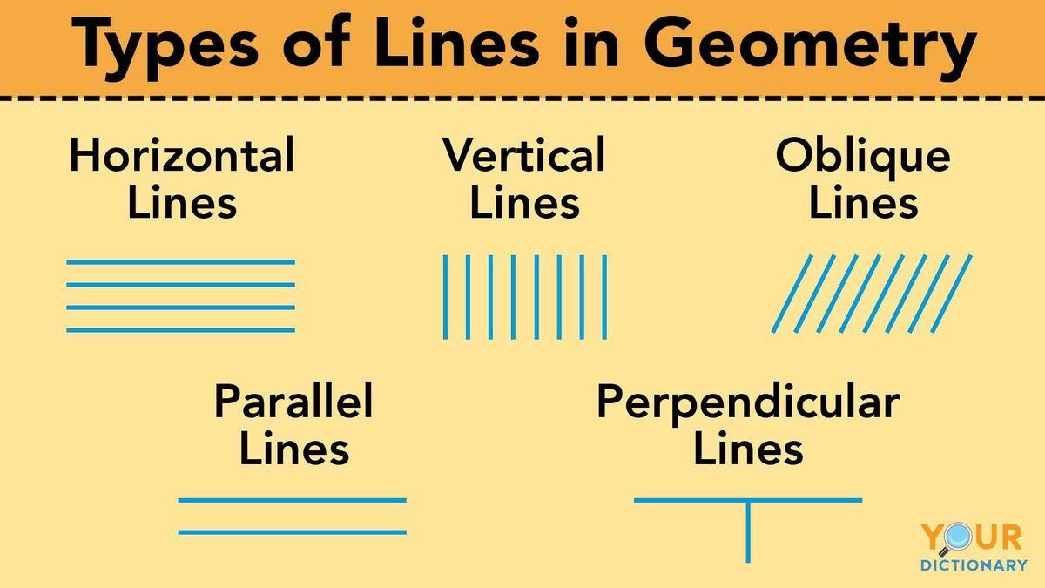
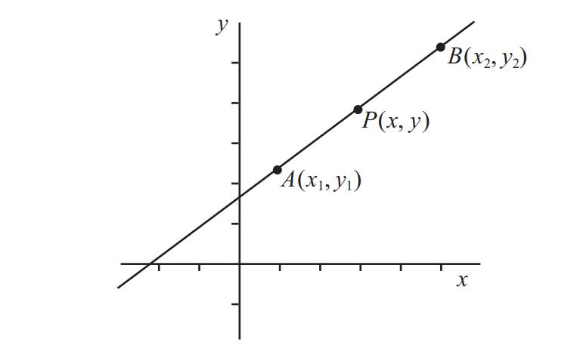
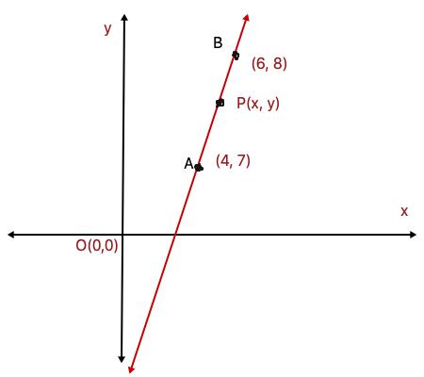

Definition
# Source: AI Source: Provided by: [Data Path: Persons Table -> ID Column: 1, Name_En Column: Motasem Essam] -> From: [ChatGPT] on [7/25/2026]
A Straight-Line Path is a geometric path in which a moving point travels continuously along a single straight line without changing direction.
If a point $P$moves along a line $l$, then:
$$\boxed{Path⁡\left(P\right)=l}$$
A straight-line path has:
- constant direction,
- no turning,
- zero curvature,
- and the shortest distance between two points when restricted to the segment connecting them.
Simple Definition
A Straight-Line Path is the path traced by a moving point when it moves continuously in one fixed direction without turning.

Main Types of Straight-Line Paths
# Source: AI Source: Provided by: [Data Path: Persons Table -> ID Column: 1, Name_En Column: Motasem Essam] -> From: [ChatGPT] on [7/25/2026]
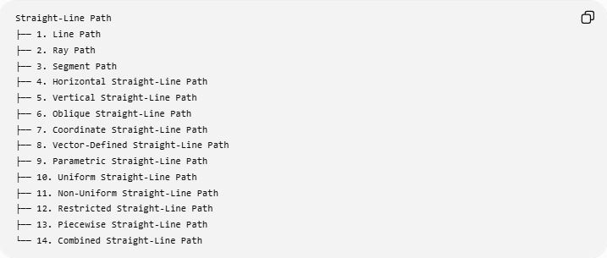
Straight-Line Path
├── 1. Line Path
├── 2. Ray Path
├── 3. Segment Path
├── 4. Horizontal Straight-Line Path
├── 5. Vertical Straight-Line Path
├── 6. Oblique Straight-Line Path
├── 7. Coordinate Straight-Line Path
├── 8. Vector-Defined Straight-Line Path
├── 9. Parametric Straight-Line Path
├── 10. Uniform Straight-Line Path
├── 11. Non-Uniform Straight-Line Path
├── 12. Restricted Straight-Line Path
├── 13. Piecewise Straight-Line Path
└── 14. Combined Straight-Line Path

1. Line Path
# Source: AI Source: Provided by: [Data Path: Persons Table -> ID Column: 1, Name_En Column: Motasem Essam] -> From: [ChatGPT] on [7/25/2026]
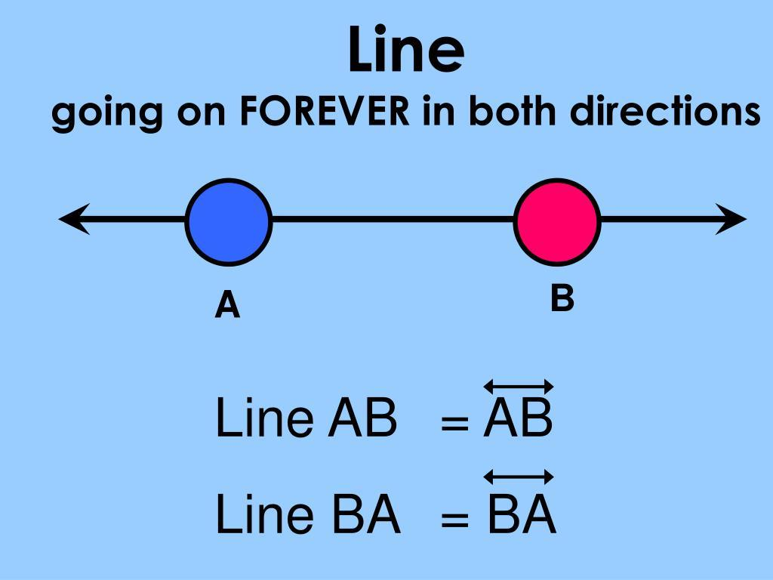
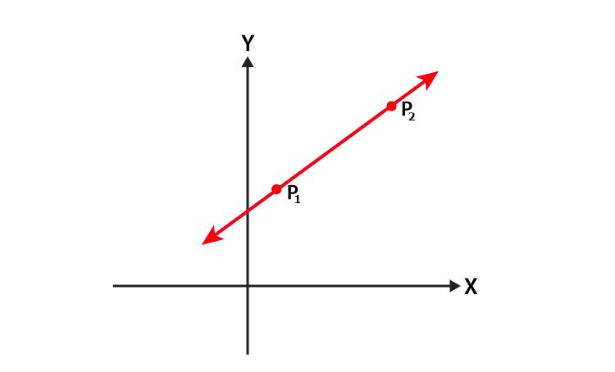
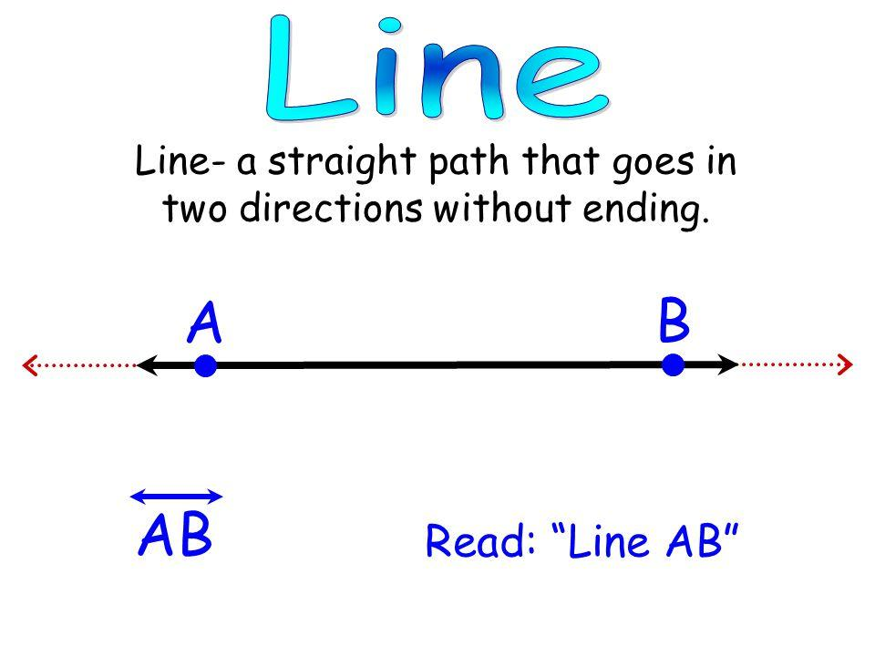
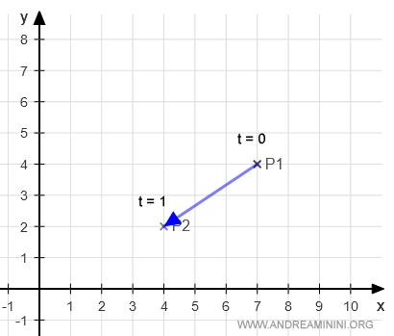
Definition
A Line Path extends infinitely in both directions.
It is represented by:
$$\boxed{\overset{↔}{AB}}$$
Example
If a point moves along:
$$y=2x+1,$$
its path is the entire line:
$$\boxed{y=2x+1}$$
There are no endpoints.

2. Ray Path
# Source: AI Source: Provided by: [Data Path: Persons Table -> ID Column: 1, Name_En Column: Motasem Essam] -> From: [ChatGPT] on [7/25/2026]
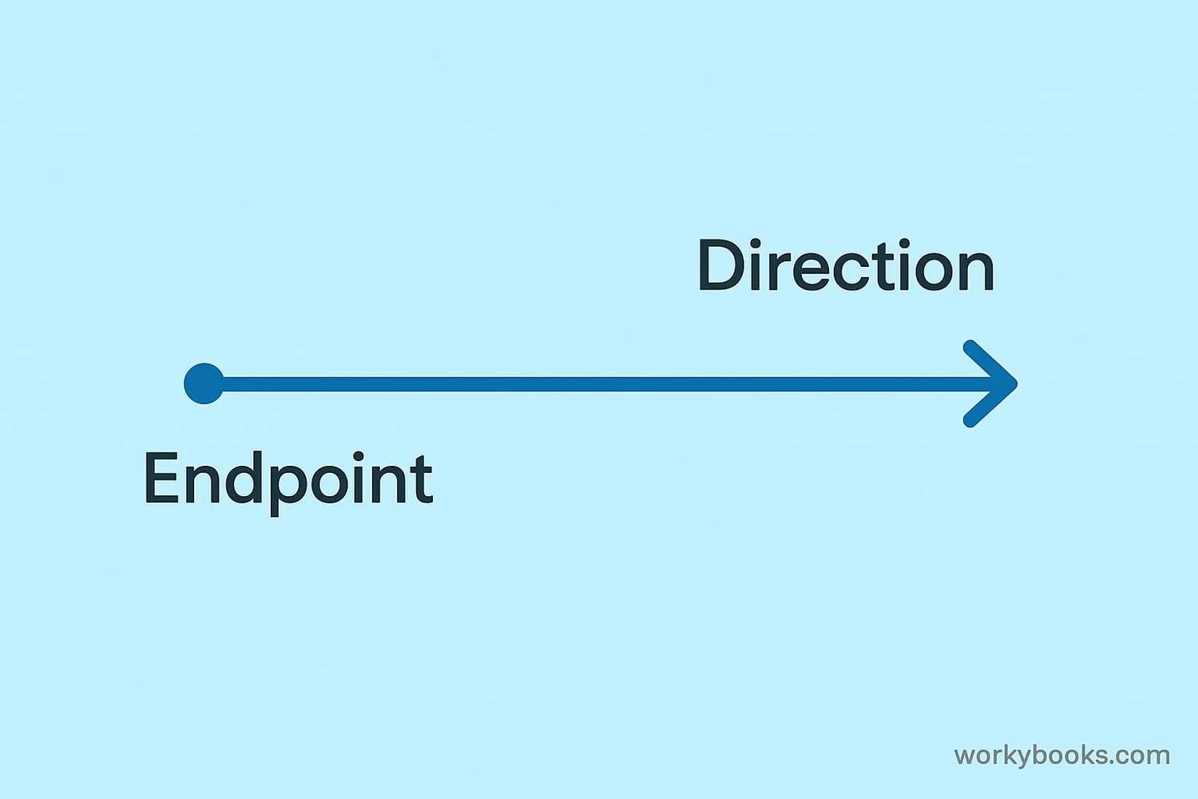
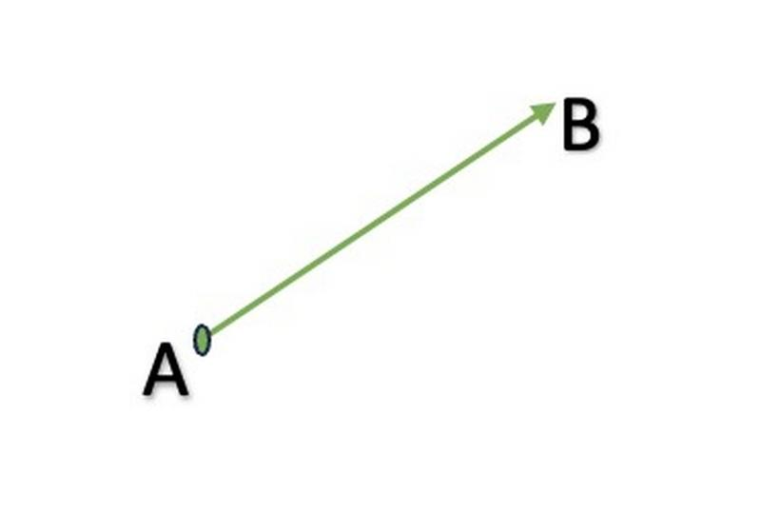
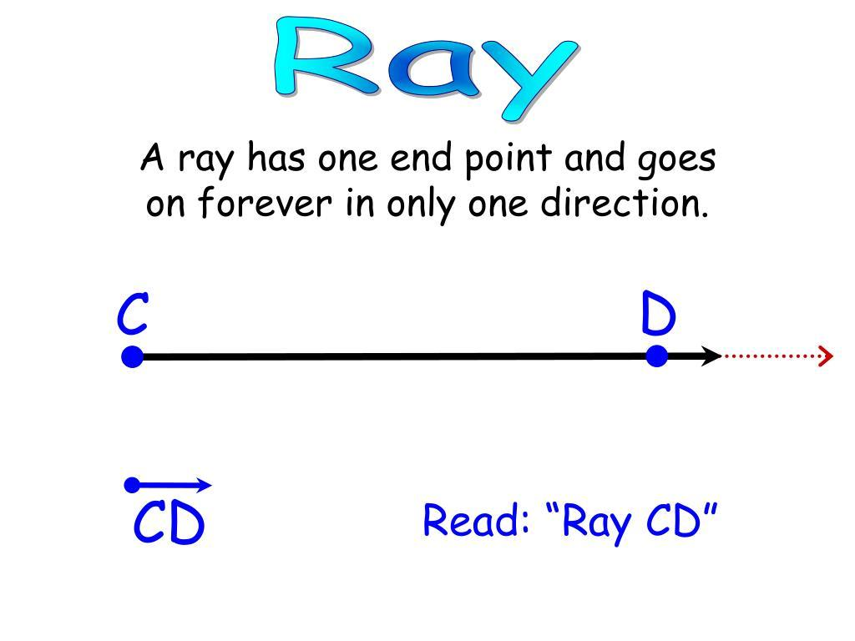
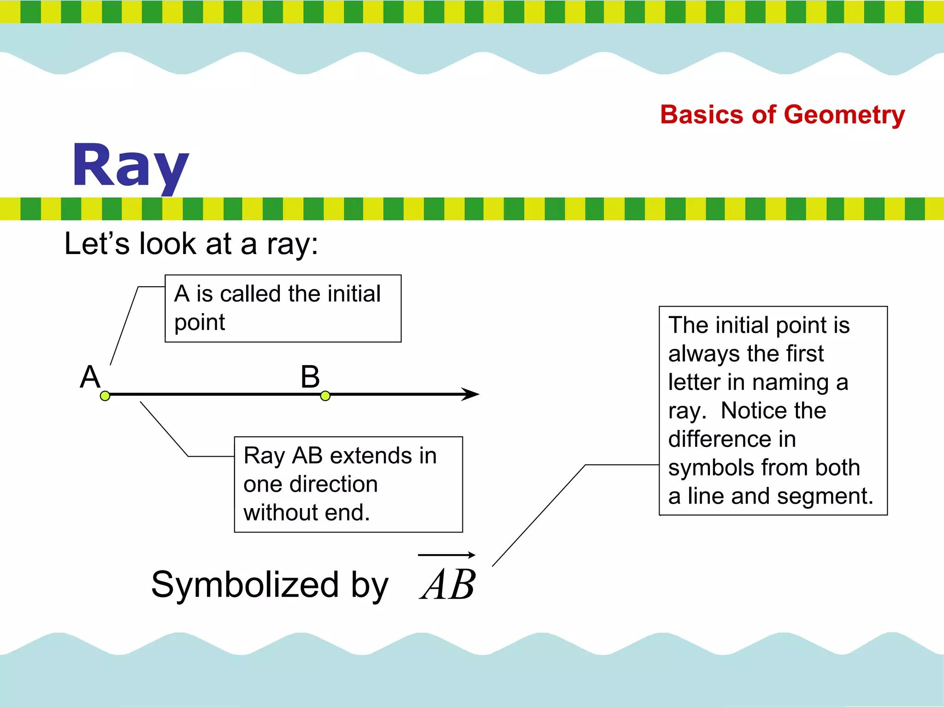
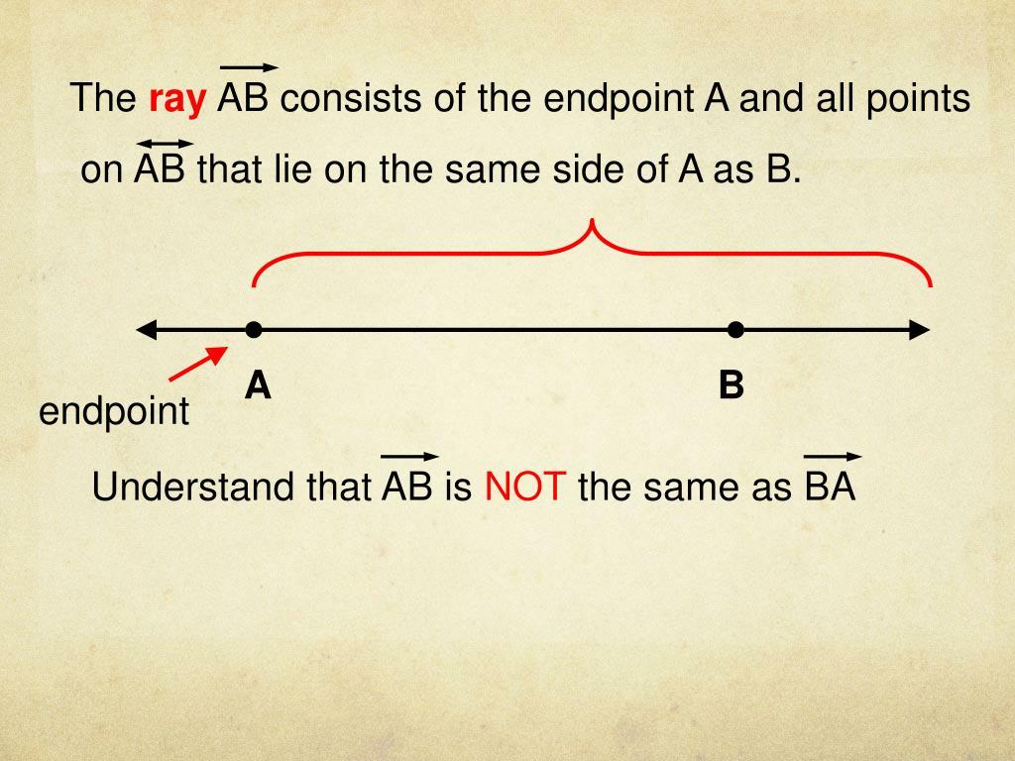
Definition
A Ray Path starts at one endpoint and continues indefinitely in one direction.
It is represented by:
$$\boxed{\vec{AB}}$$
where $A$is the endpoint.
Example
A point starts at $A$, passes through $B$, and continues indefinitely:
$$\boxed{A⟶B⟶⋯}$$

3. Segment Path
# Source: AI Source: Provided by: [Data Path: Persons Table -> ID Column: 1, Name_En Column: Motasem Essam] -> From: [ChatGPT] on [7/25/2026]
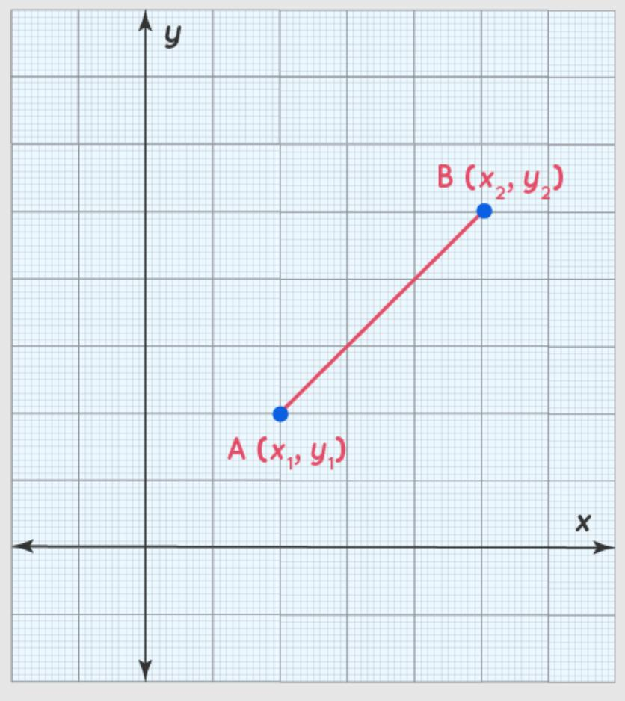
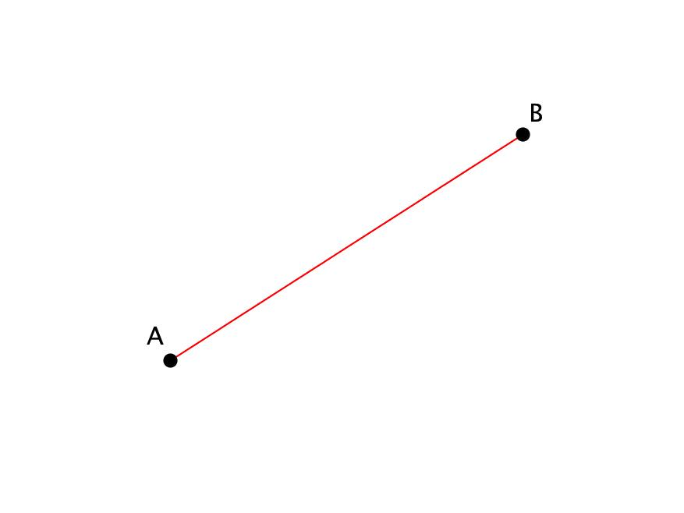
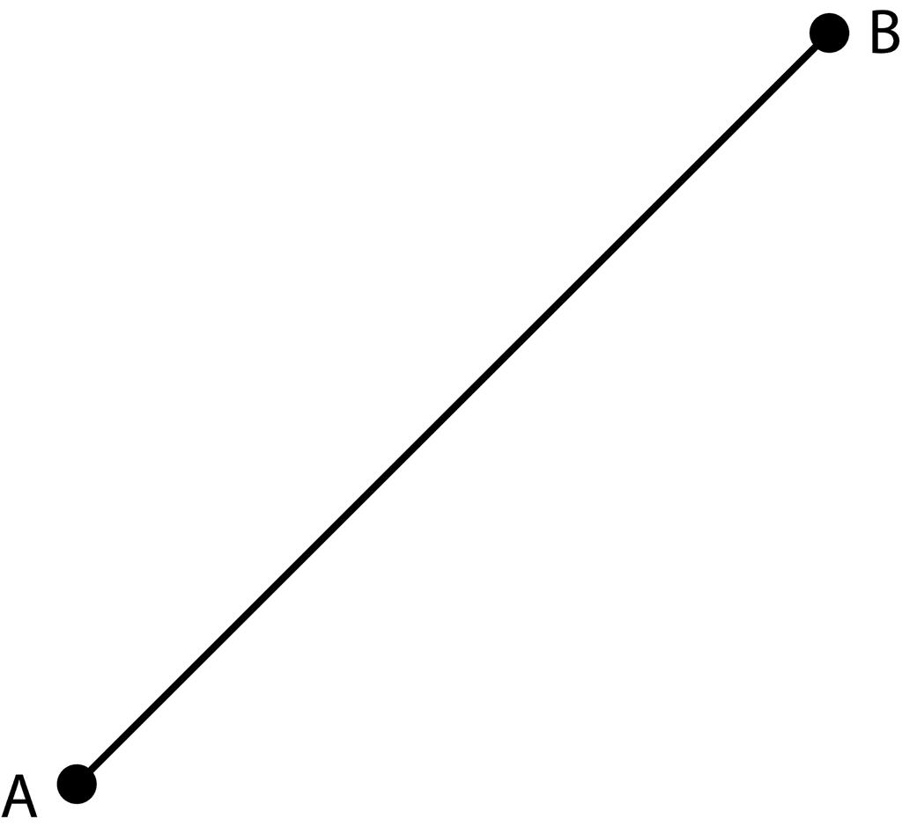
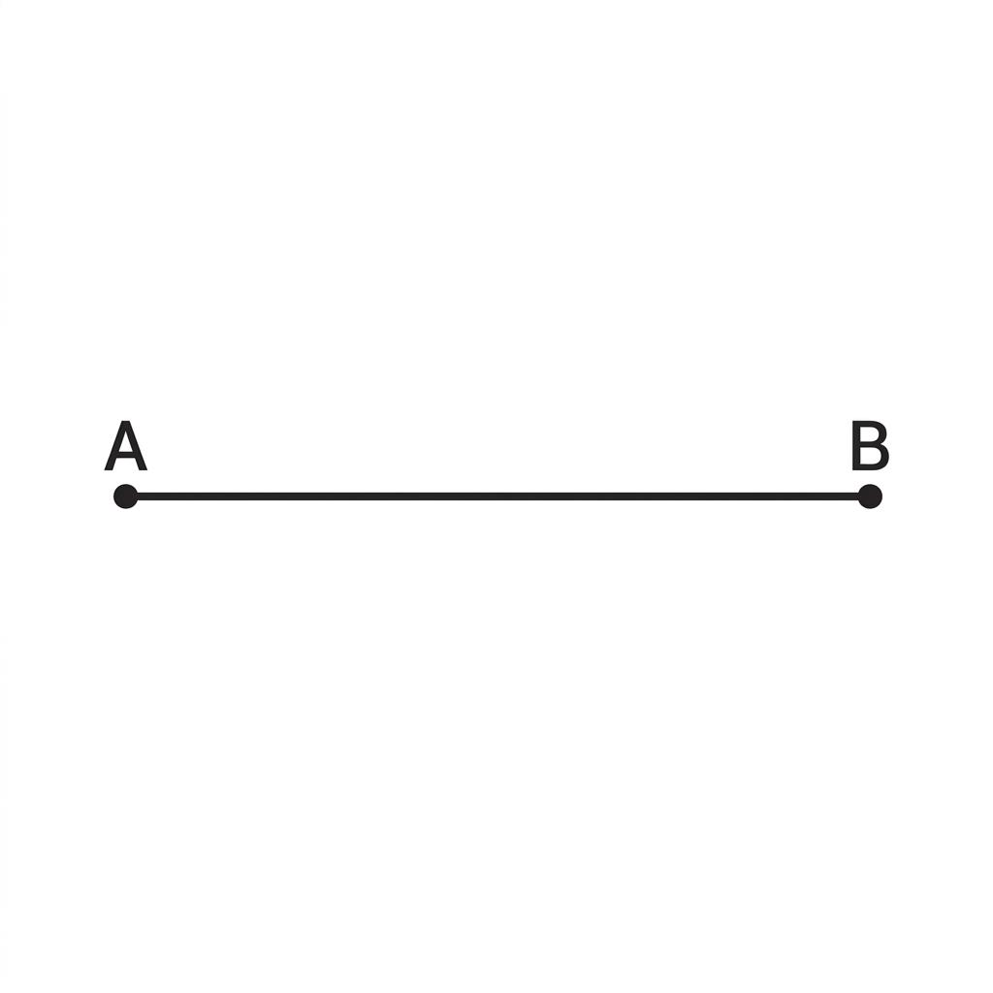
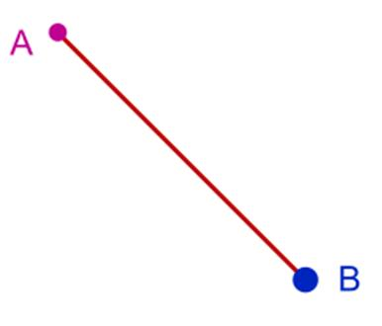
Definition
A Segment Path is a finite straight path between two endpoints.
It is represented by:
$$\boxed{\overset{‾}{AB}}$$
Example
A point moves from:
$$A=\left(1 , 2\right)$$
to:
$$B=\left(5 , 4\right).$$
Its path is:
$$\boxed{\overset{‾}{AB}}$$
and its length is:
$$AB=\sqrt{{\left(5-1\right)}^{2}+{\left(4-2\right)}^{2}}=2\sqrt{5}.$$

4. Horizontal Straight-Line Path
# Source: AI Source: Provided by: [Data Path: Persons Table -> ID Column: 1, Name_En Column: Motasem Essam] -> From: [ChatGPT] on [7/25/2026]
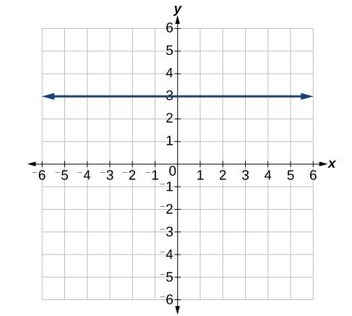
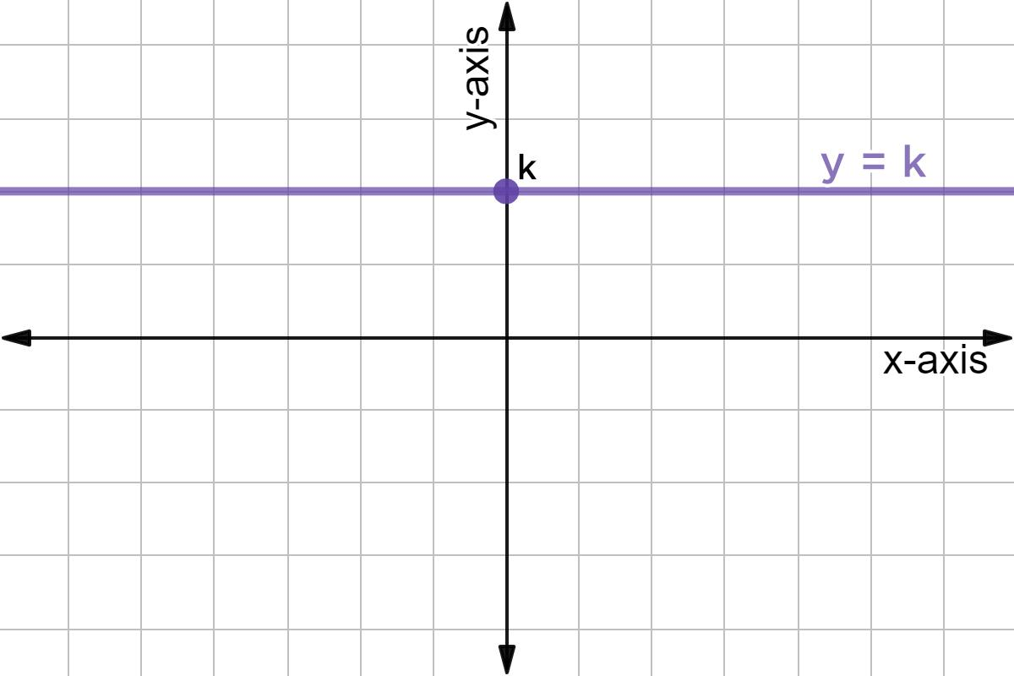
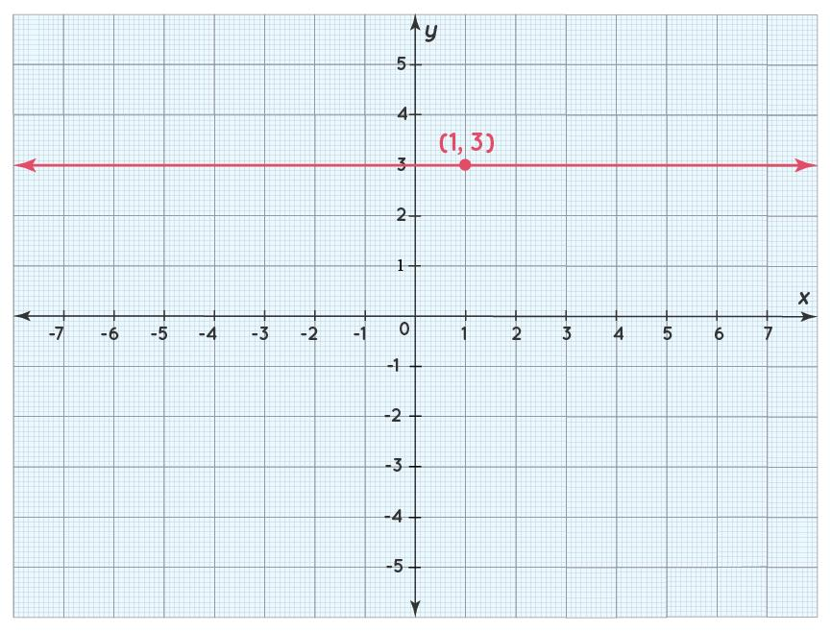
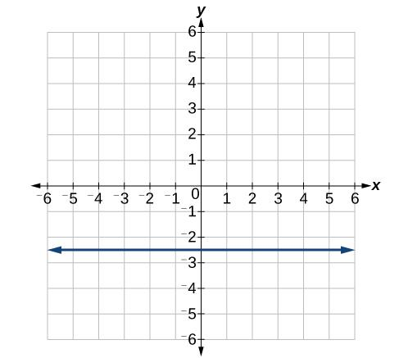
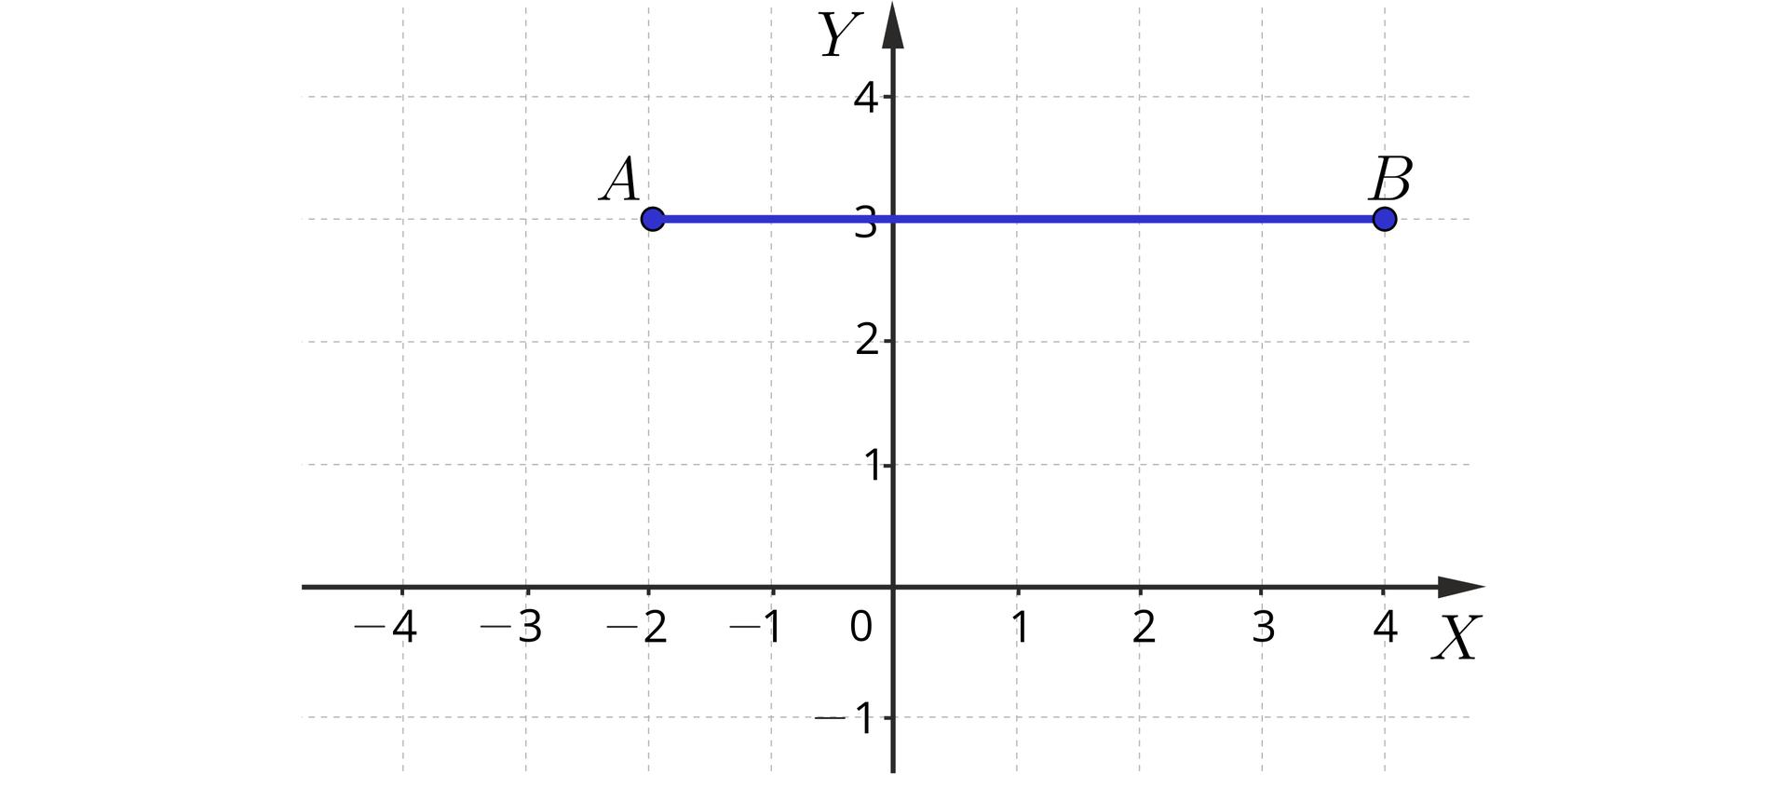
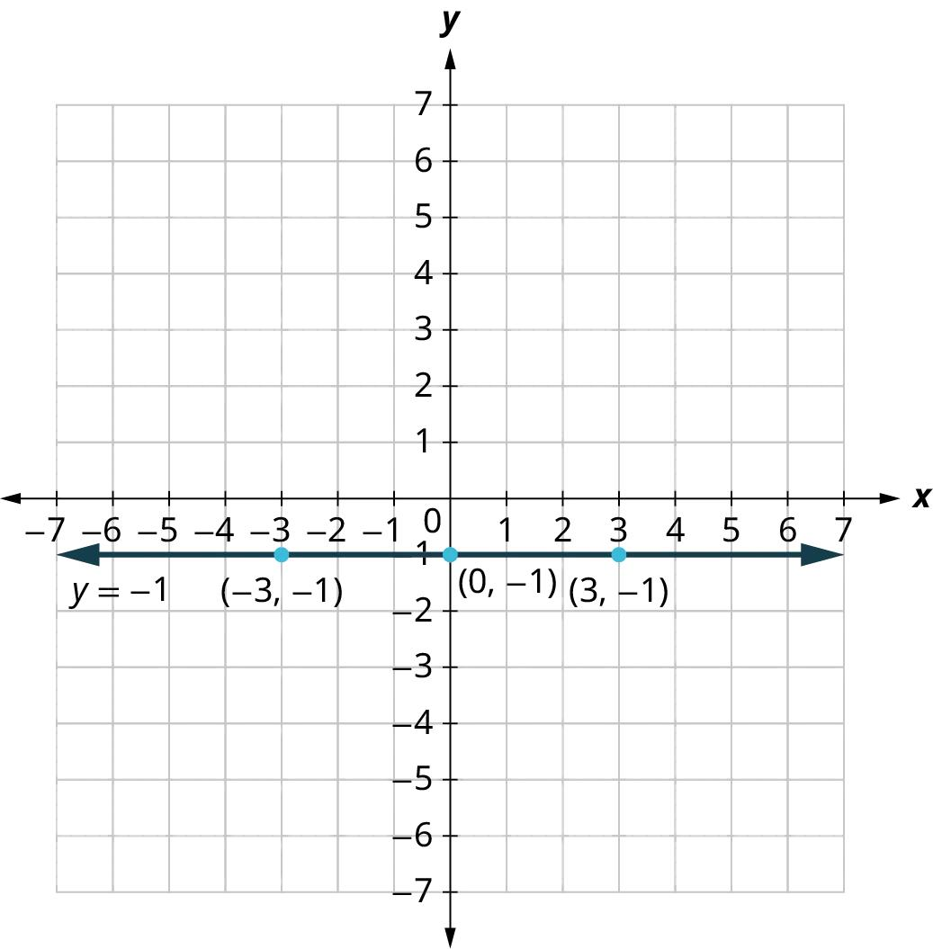
Definition
A Horizontal Straight-Line Path is parallel to the $x$-axis.
Its equation is:
$$\boxed{y=c}$$
Example
$$y=4$$
is a horizontal straight-line path.
Every point on it has the form:
$$\left(x , 4\right).$$
Its direction vector can be:
$$\boxed{\left(1 , 0\right)}$$

5. Vertical Straight-Line Path
# Source: AI Source: Provided by: [Data Path: Persons Table -> ID Column: 1, Name_En Column: Motasem Essam] -> From: [ChatGPT] on [7/25/2026]
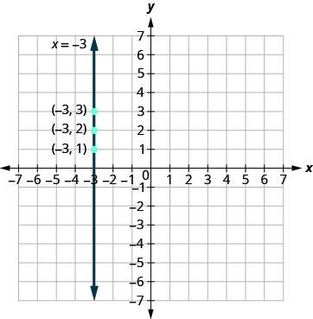
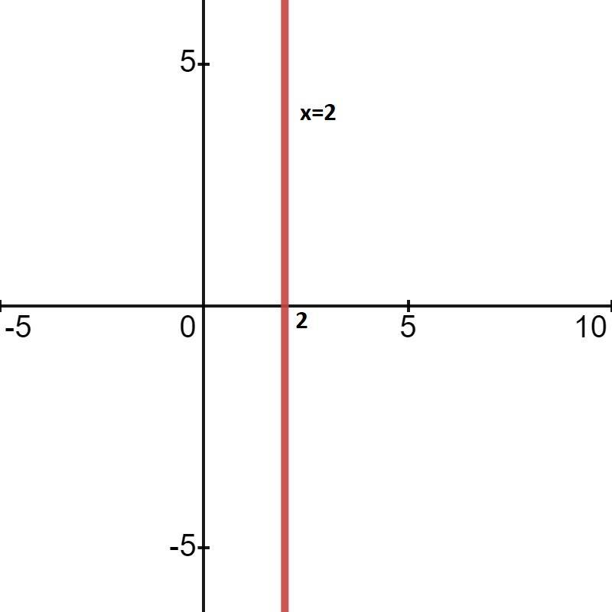
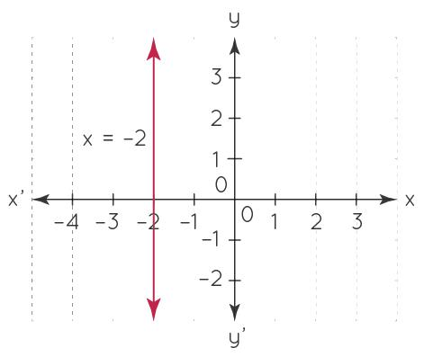
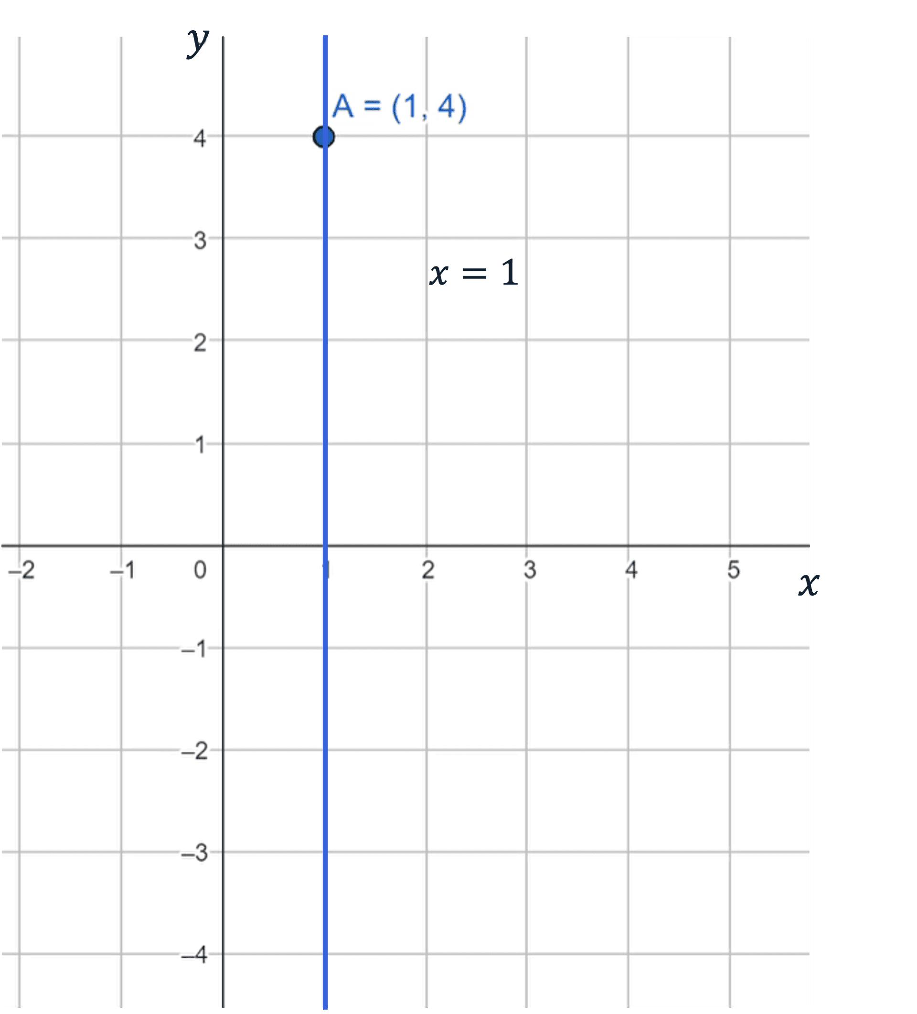
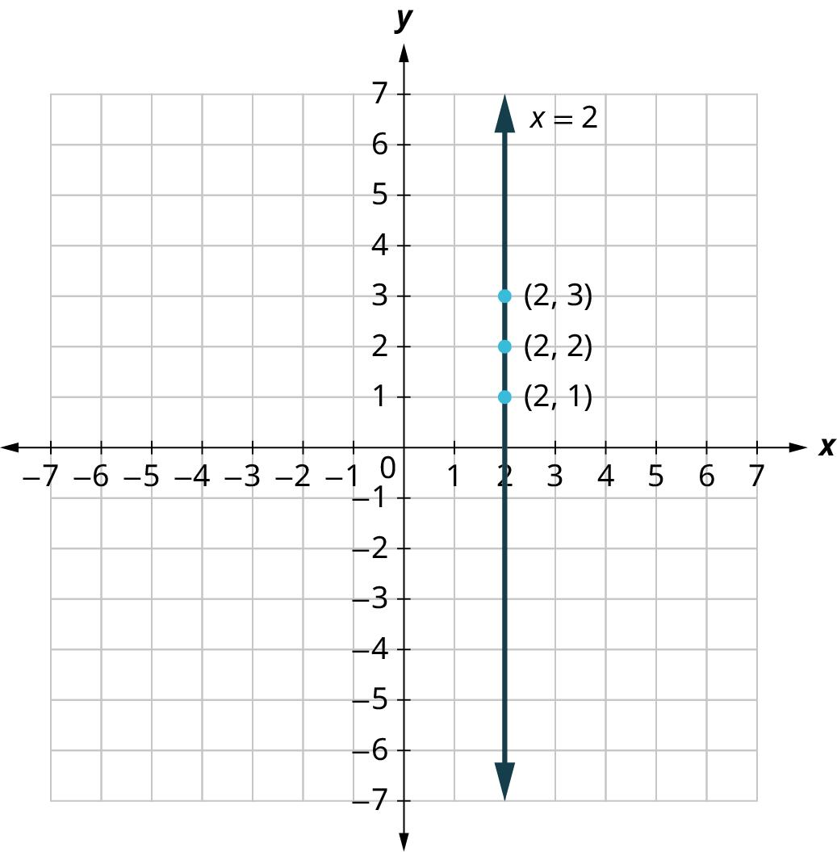
Definition
A Vertical Straight-Line Path is parallel to the $y$-axis.
Its equation is:
$$\boxed{x=c}$$
Example
$$x=3$$
is a vertical straight-line path.
Every point on it has the form:
$$\left(3 , y\right).$$
Its direction vector can be:
$$\boxed{\left(0 , 1\right)}$$

6. Oblique Straight-Line Path
# Source: AI Source: Provided by: [Data Path: Persons Table -> ID Column: 1, Name_En Column: Motasem Essam] -> From: [ChatGPT] on [7/25/2026]
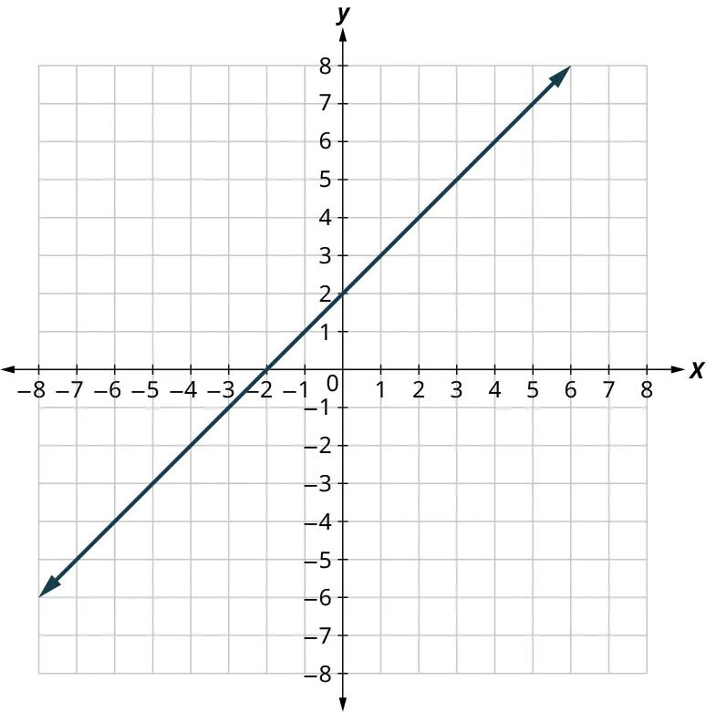
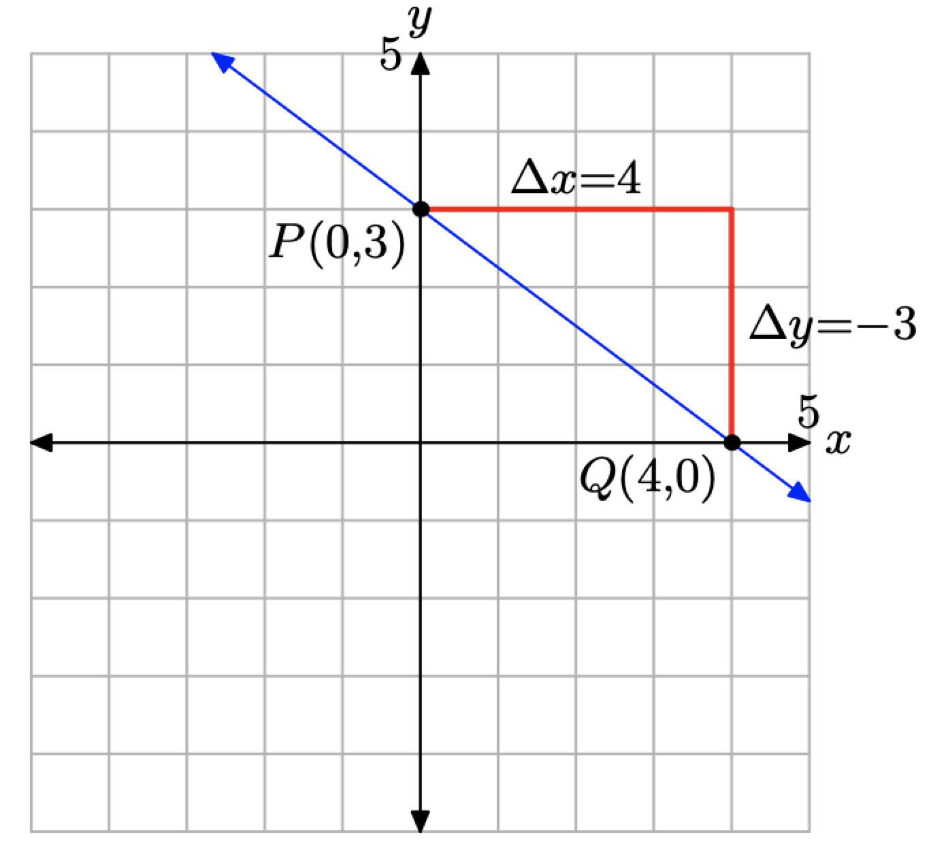
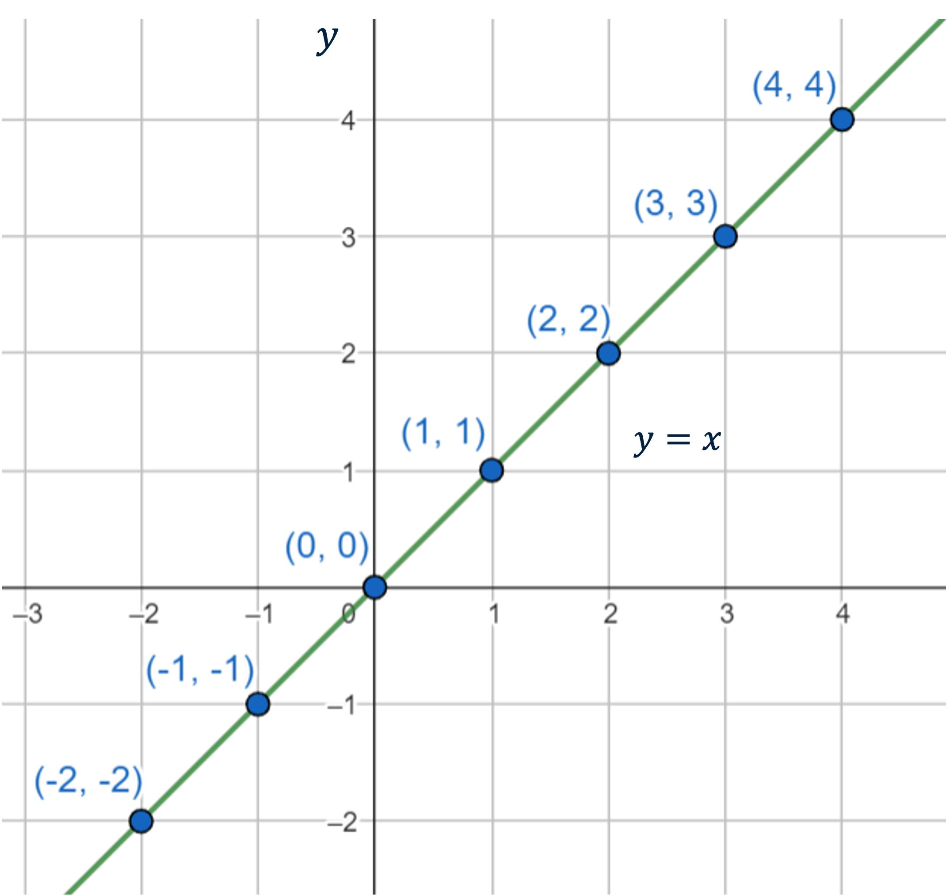
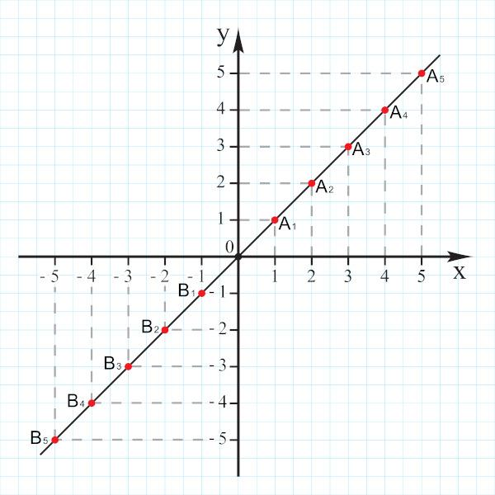
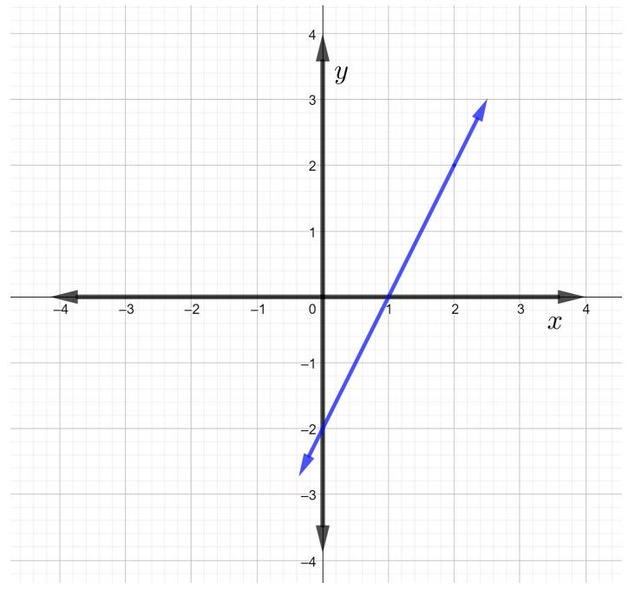
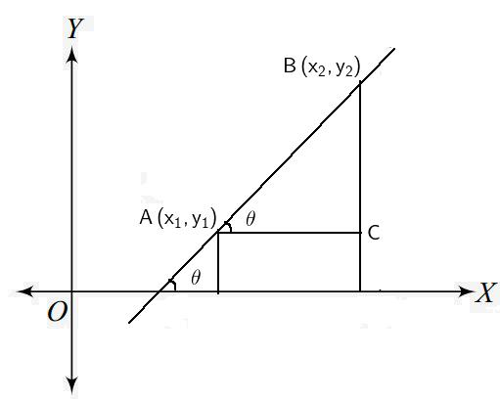
Definition
An Oblique Straight-Line Path is neither horizontal nor vertical.
For a nonvertical line:
$$\boxed{y=mx+b}$$
where $m$is the slope.
Example
$$y=2x+3$$
has:
$$m=2.$$
Therefore, the point moves along a straight path that rises $2$units for every $1$unit of horizontal movement.

7. Coordinate Straight-Line Path
# Source: AI Source: Provided by: [Data Path: Persons Table -> ID Column: 1, Name_En Column: Motasem Essam] -> From: [ChatGPT] on [7/25/2026]
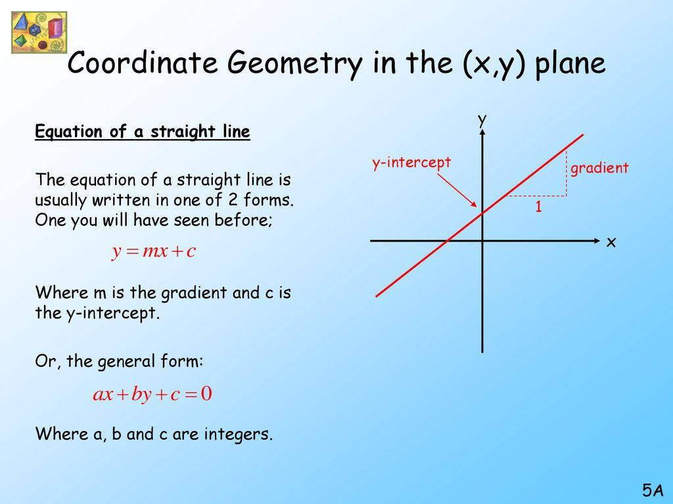
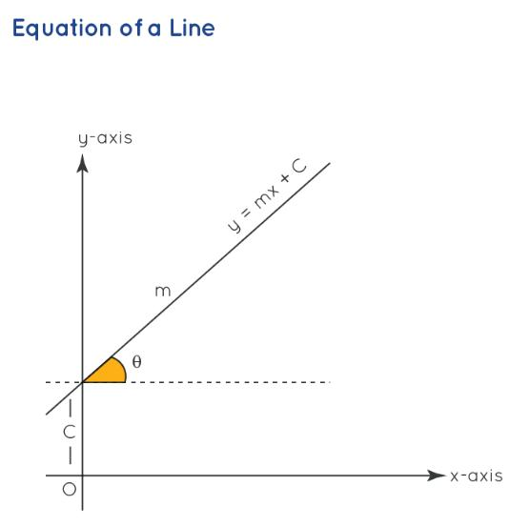
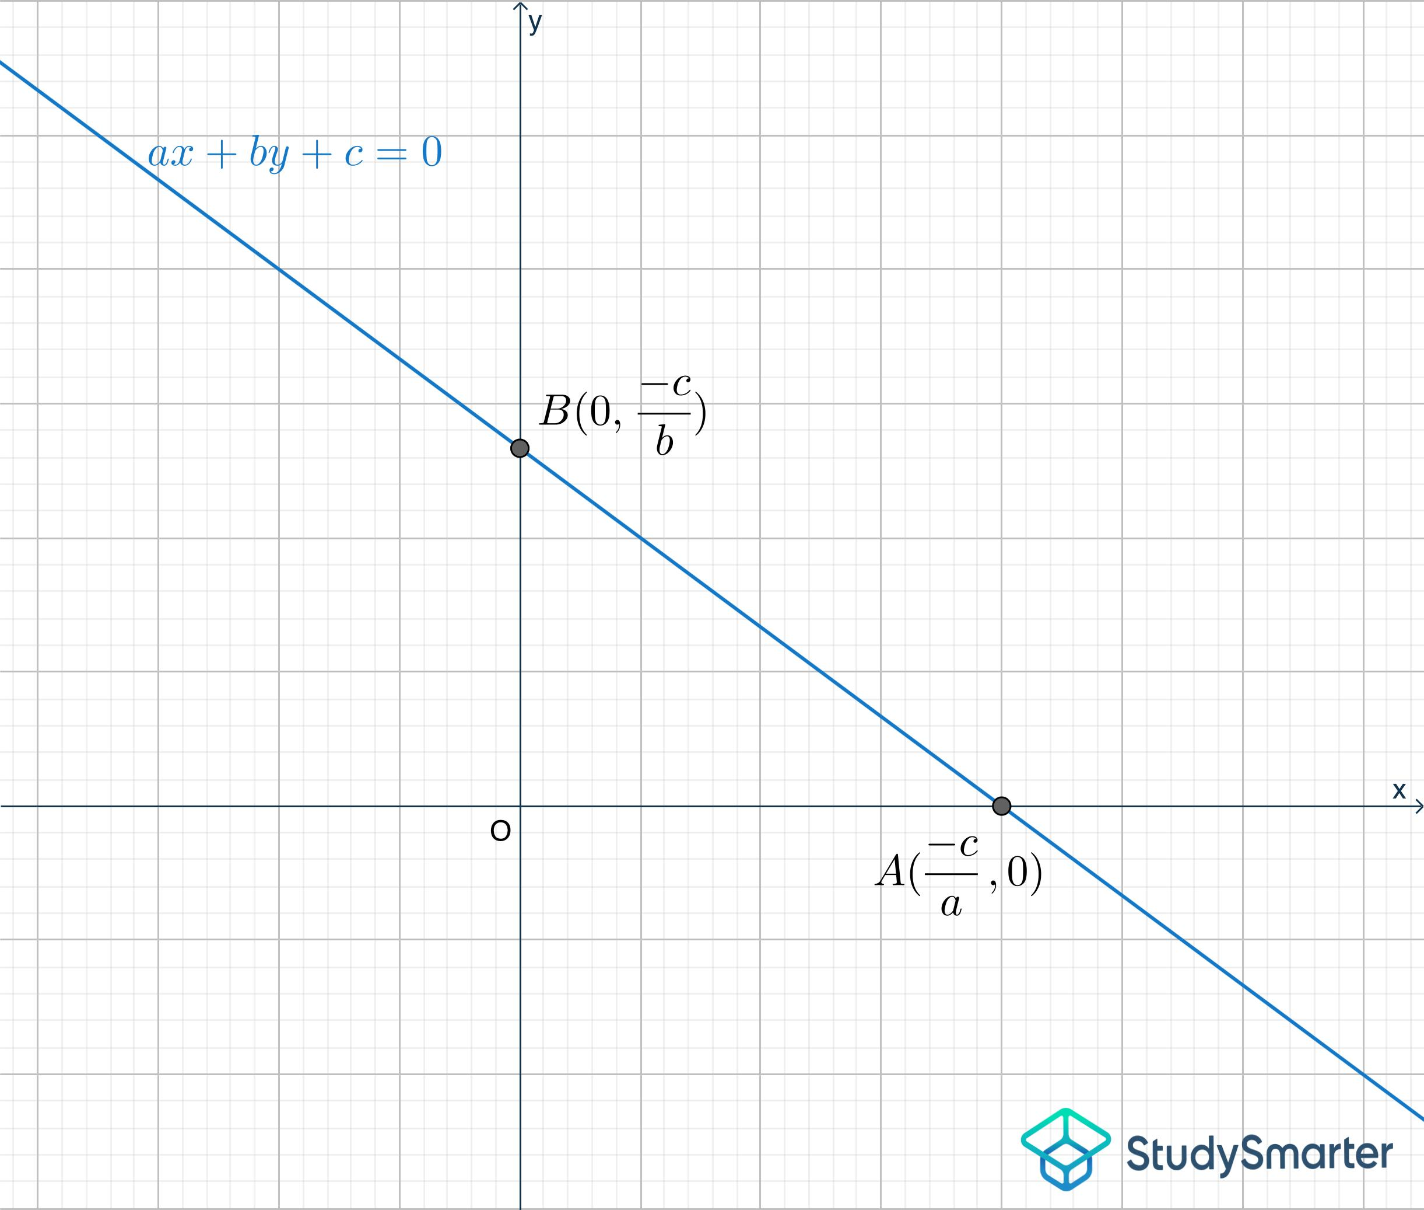
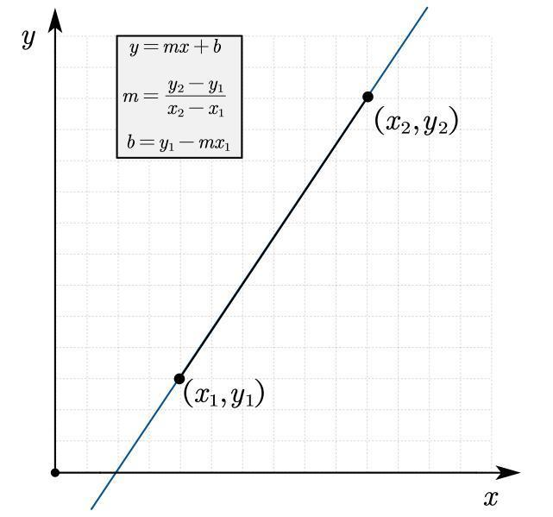
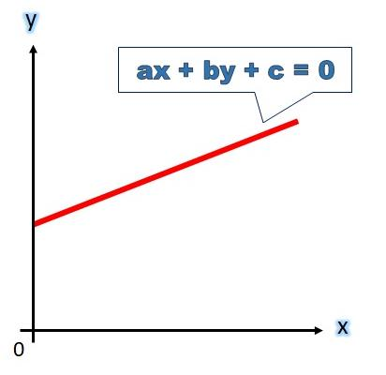
Definition
A Coordinate Straight-Line Path describes the path using coordinates.
The general equation is:
$$\boxed{ax+by+c=0}$$
where $a$and $b$are not both zero.
Example
$$2x+3y-6=0$$
can be rewritten as:
$$y=-\frac{2}{3}x+2.$$
Therefore, it represents a straight-line path with slope:
$$\boxed{-\frac{2}{3}}.$$

8. Vector-Defined Straight-Line Path
# Source: AI Source: Provided by: [Data Path: Persons Table -> ID Column: 1, Name_En Column: Motasem Essam] -> From: [ChatGPT] on [7/25/2026]
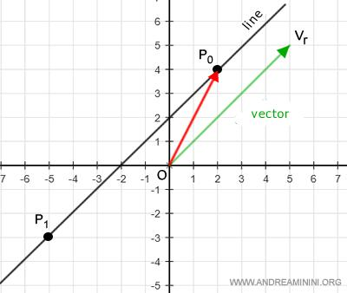
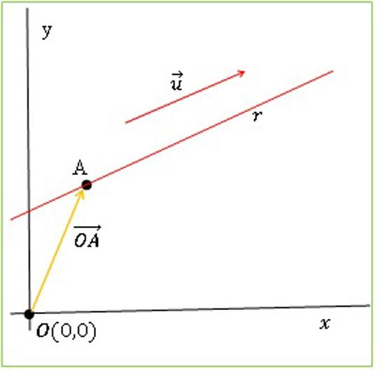
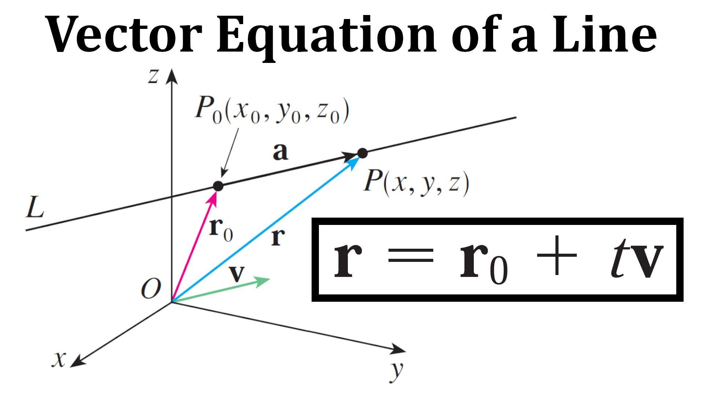
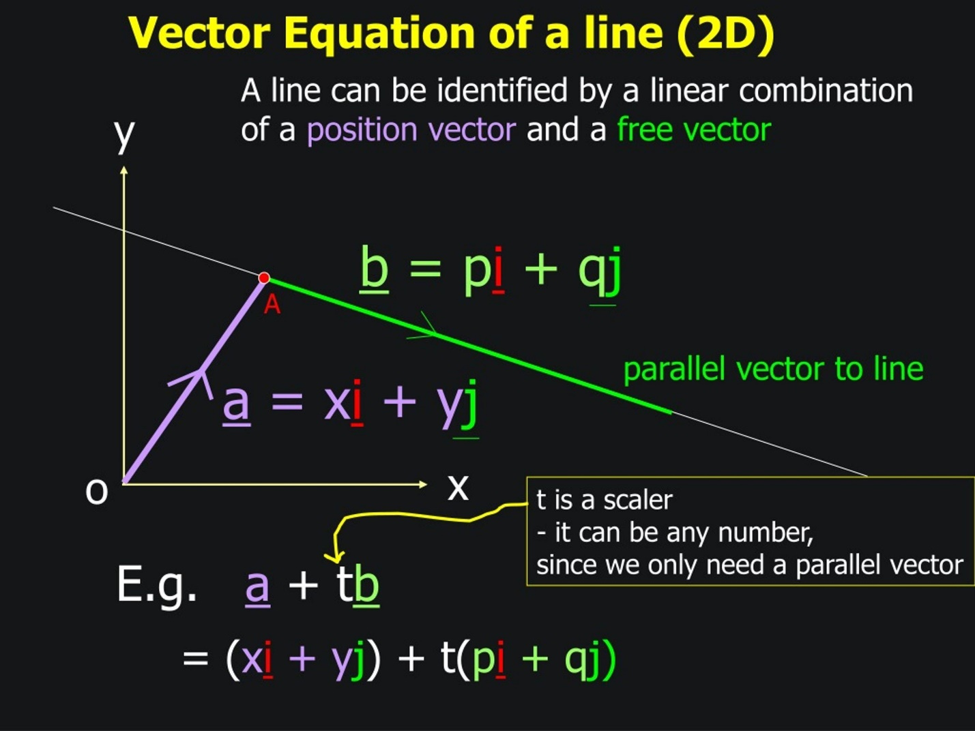
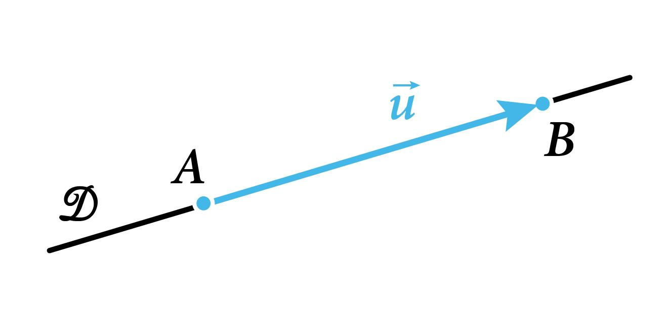
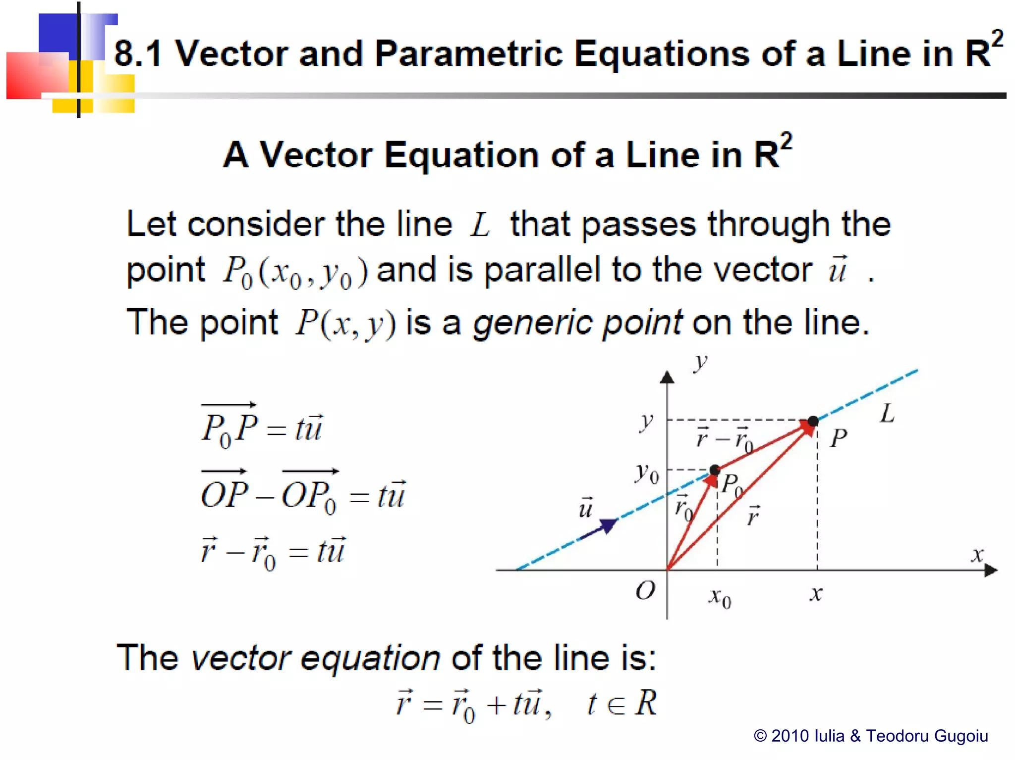
Definition
A straight path can be defined by:
- a starting point, and
- a direction vector.
The vector equation is:
$$\boxed{\vec{r}={\vec{r}}_{0}+t\vec{v}}$$
where $t∈R$.
Example
Starting at:
$$P_{0}=\left(1 , 2\right)$$
with direction:
$$\vec{v}=\left(3 , 1\right),$$
the path is:
$$\boxed{\left(x , y\right)=\left(1 , 2\right)+t\left(3 , 1\right)}$$
or:
$$x=1+3t, \\ y=2+t.$$

9. Parametric Straight-Line Path
# Source: AI Source: Provided by: [Data Path: Persons Table -> ID Column: 1, Name_En Column: Motasem Essam] -> From: [ChatGPT] on [7/25/2026]
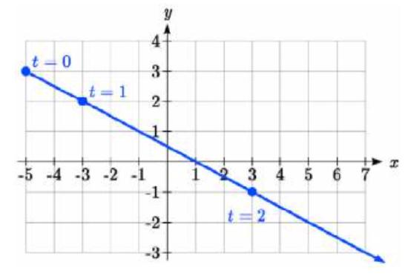
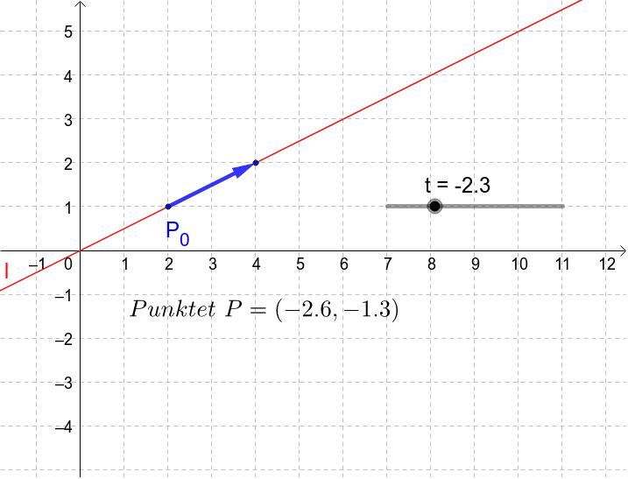
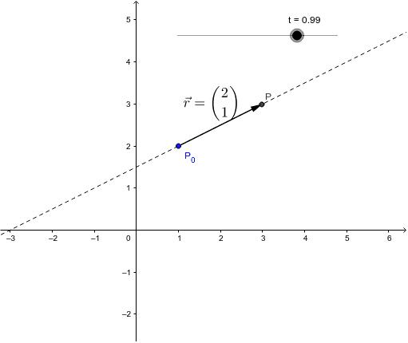
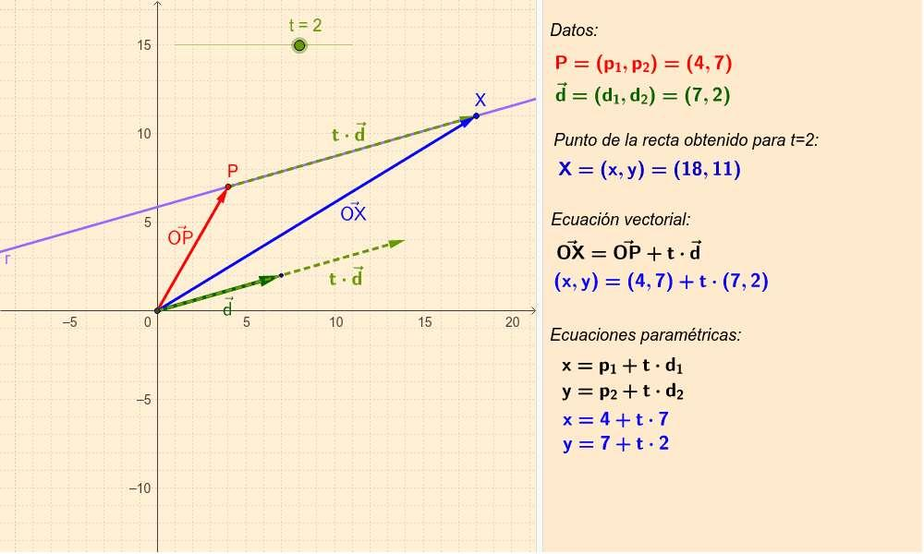
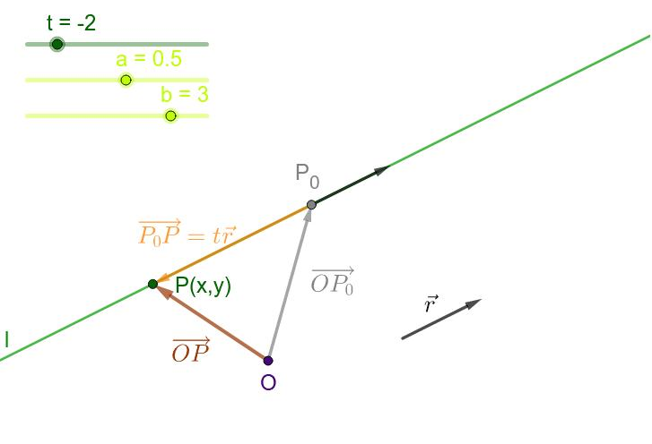
Definition
A Parametric Straight-Line Path describes the position of a moving point using a parameter $t$.
$$\boxed{x=x_{0}+at, y=y_{0}+bt}$$
Example
$$x=2+t \\ y=3+2t.$$
When:
$$t=0,$$
the point is:
$$\left(2 , 3\right).$$
When:
$$t=1,$$
the point is:
$$\left(3 , 5\right).$$
As $t$changes, the point traces a straight line.

10. Uniform Straight-Line Path
# Source: AI Source: Provided by: [Data Path: Persons Table -> ID Column: 1, Name_En Column: Motasem Essam] -> From: [ChatGPT] on [7/25/2026]
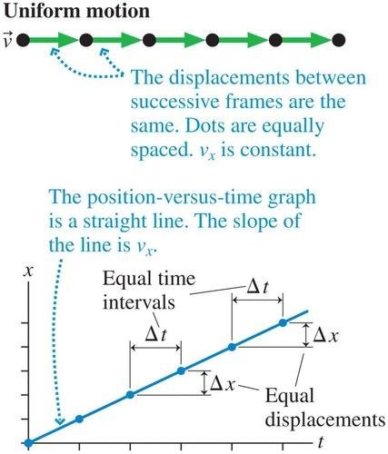
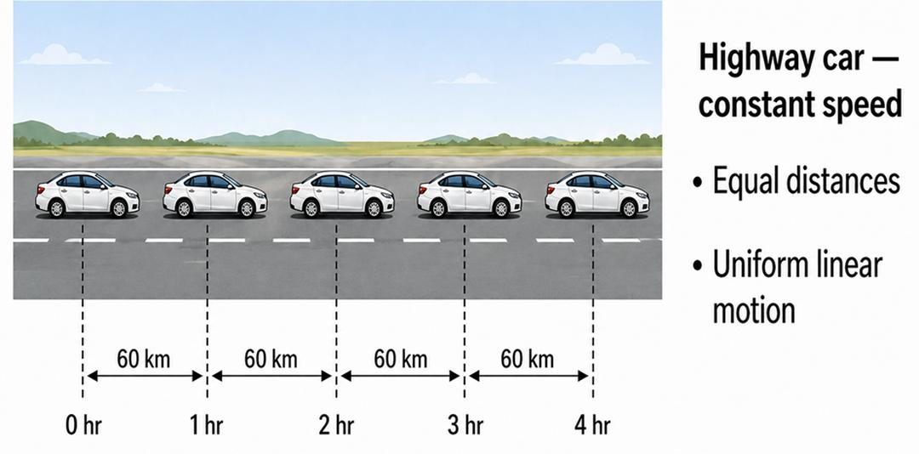
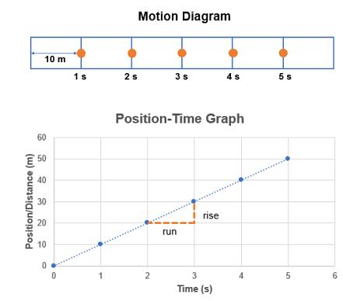
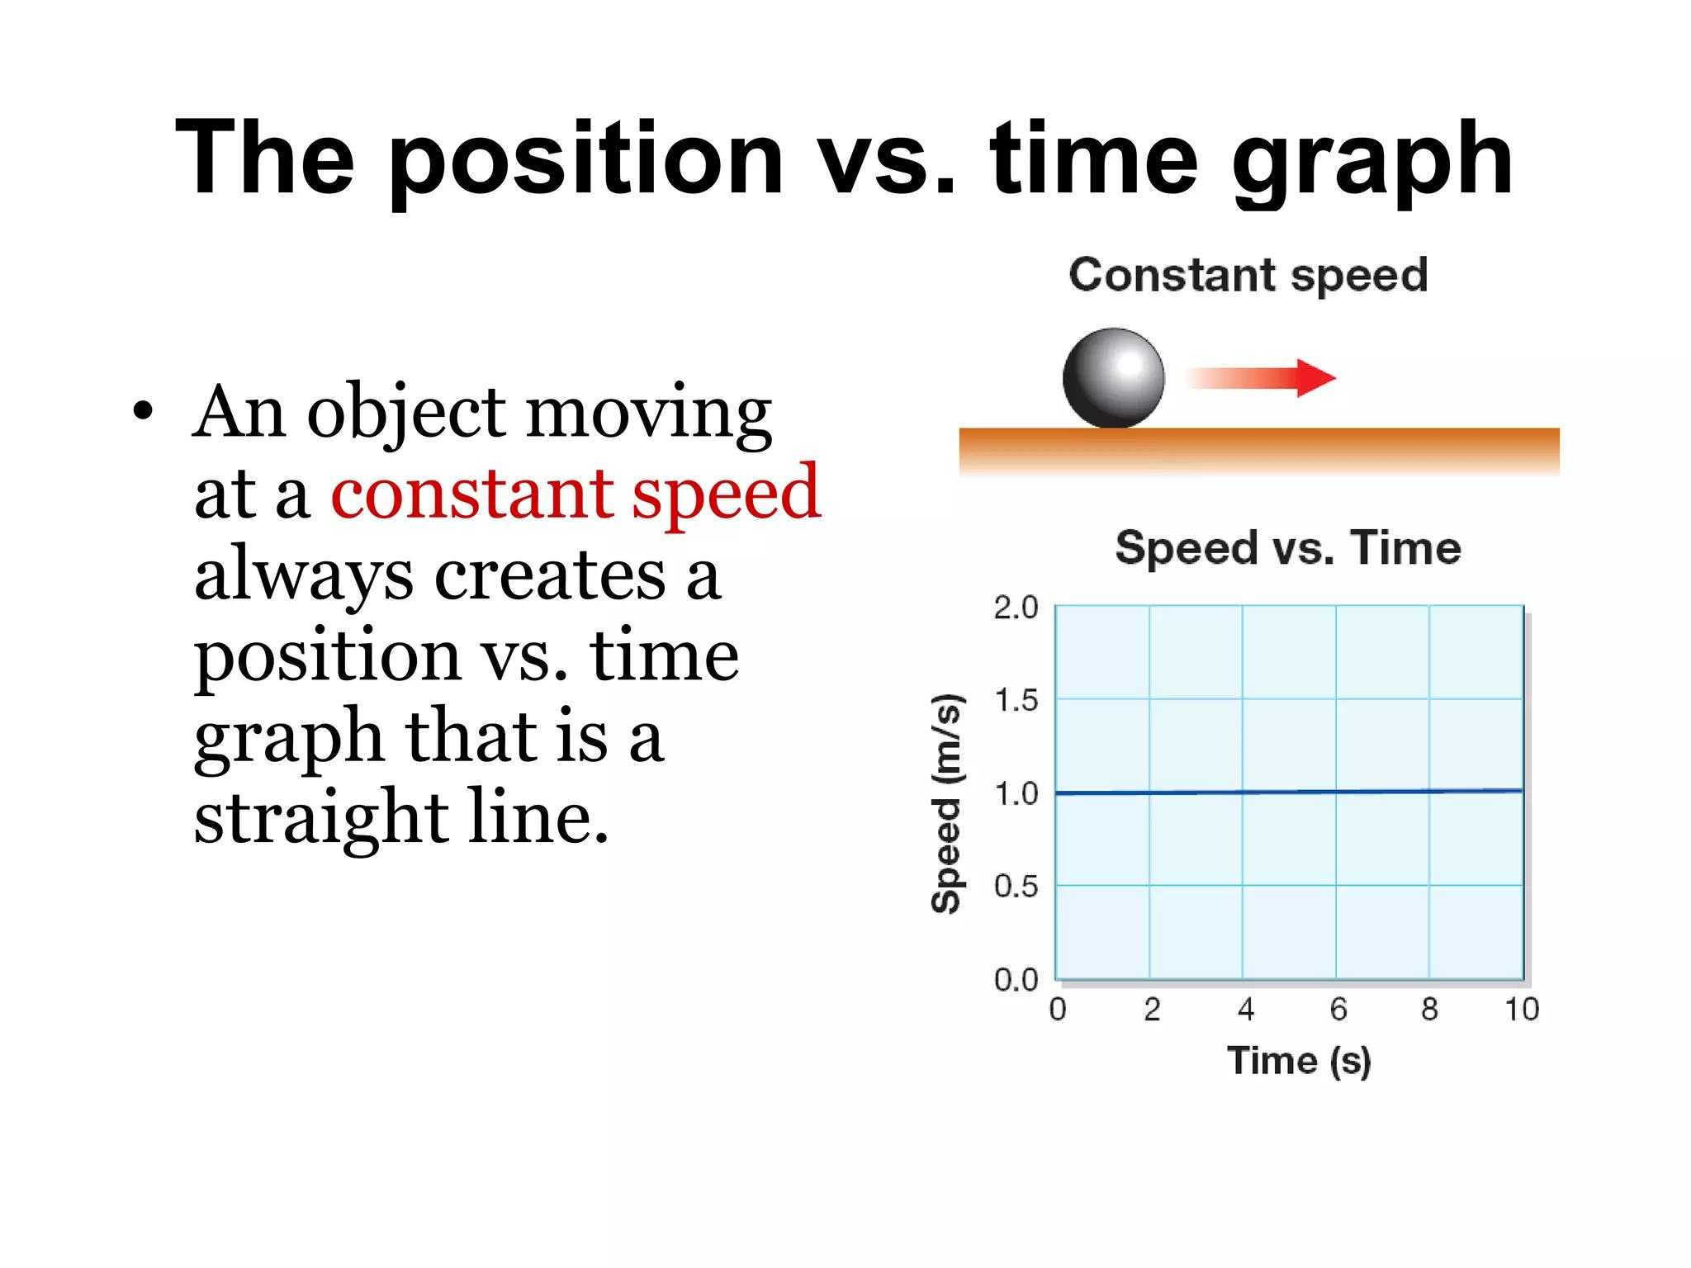
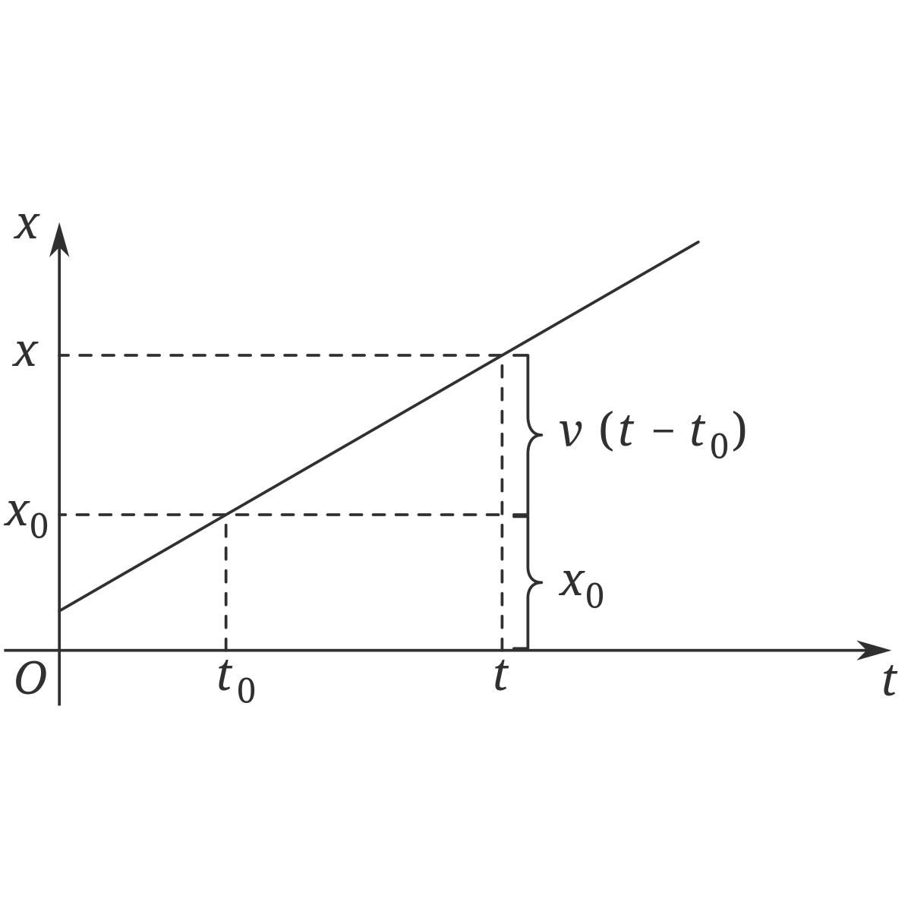
Definition
A Uniform Straight-Line Path is a straight path traversed with constant speed.
A simple one-dimensional model is:
$$\boxed{x\left(t\right)=x_{0}+vt}$$
where $v$is constant.
Example
If:
$$x_{0}=5$$
and:
$$v=3\text{ m/s},$$
then:
$$\boxed{x\left(t\right)=5+3t}.$$
The path is straight and the speed is constant.

11. Non-Uniform Straight-Line Path
# Source: AI Source: Provided by: [Data Path: Persons Table -> ID Column: 1, Name_En Column: Motasem Essam] -> From: [ChatGPT] on [7/25/2026]
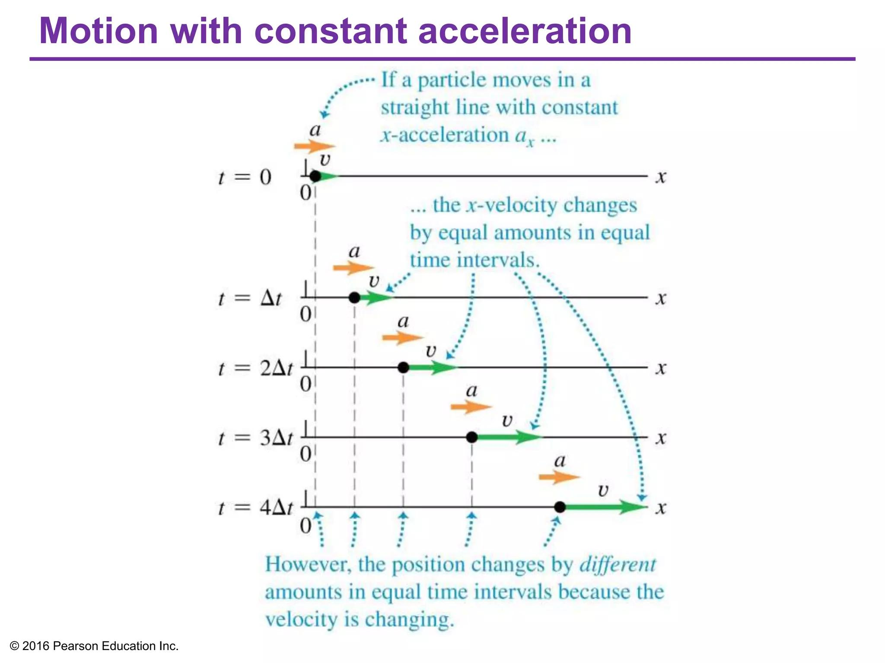
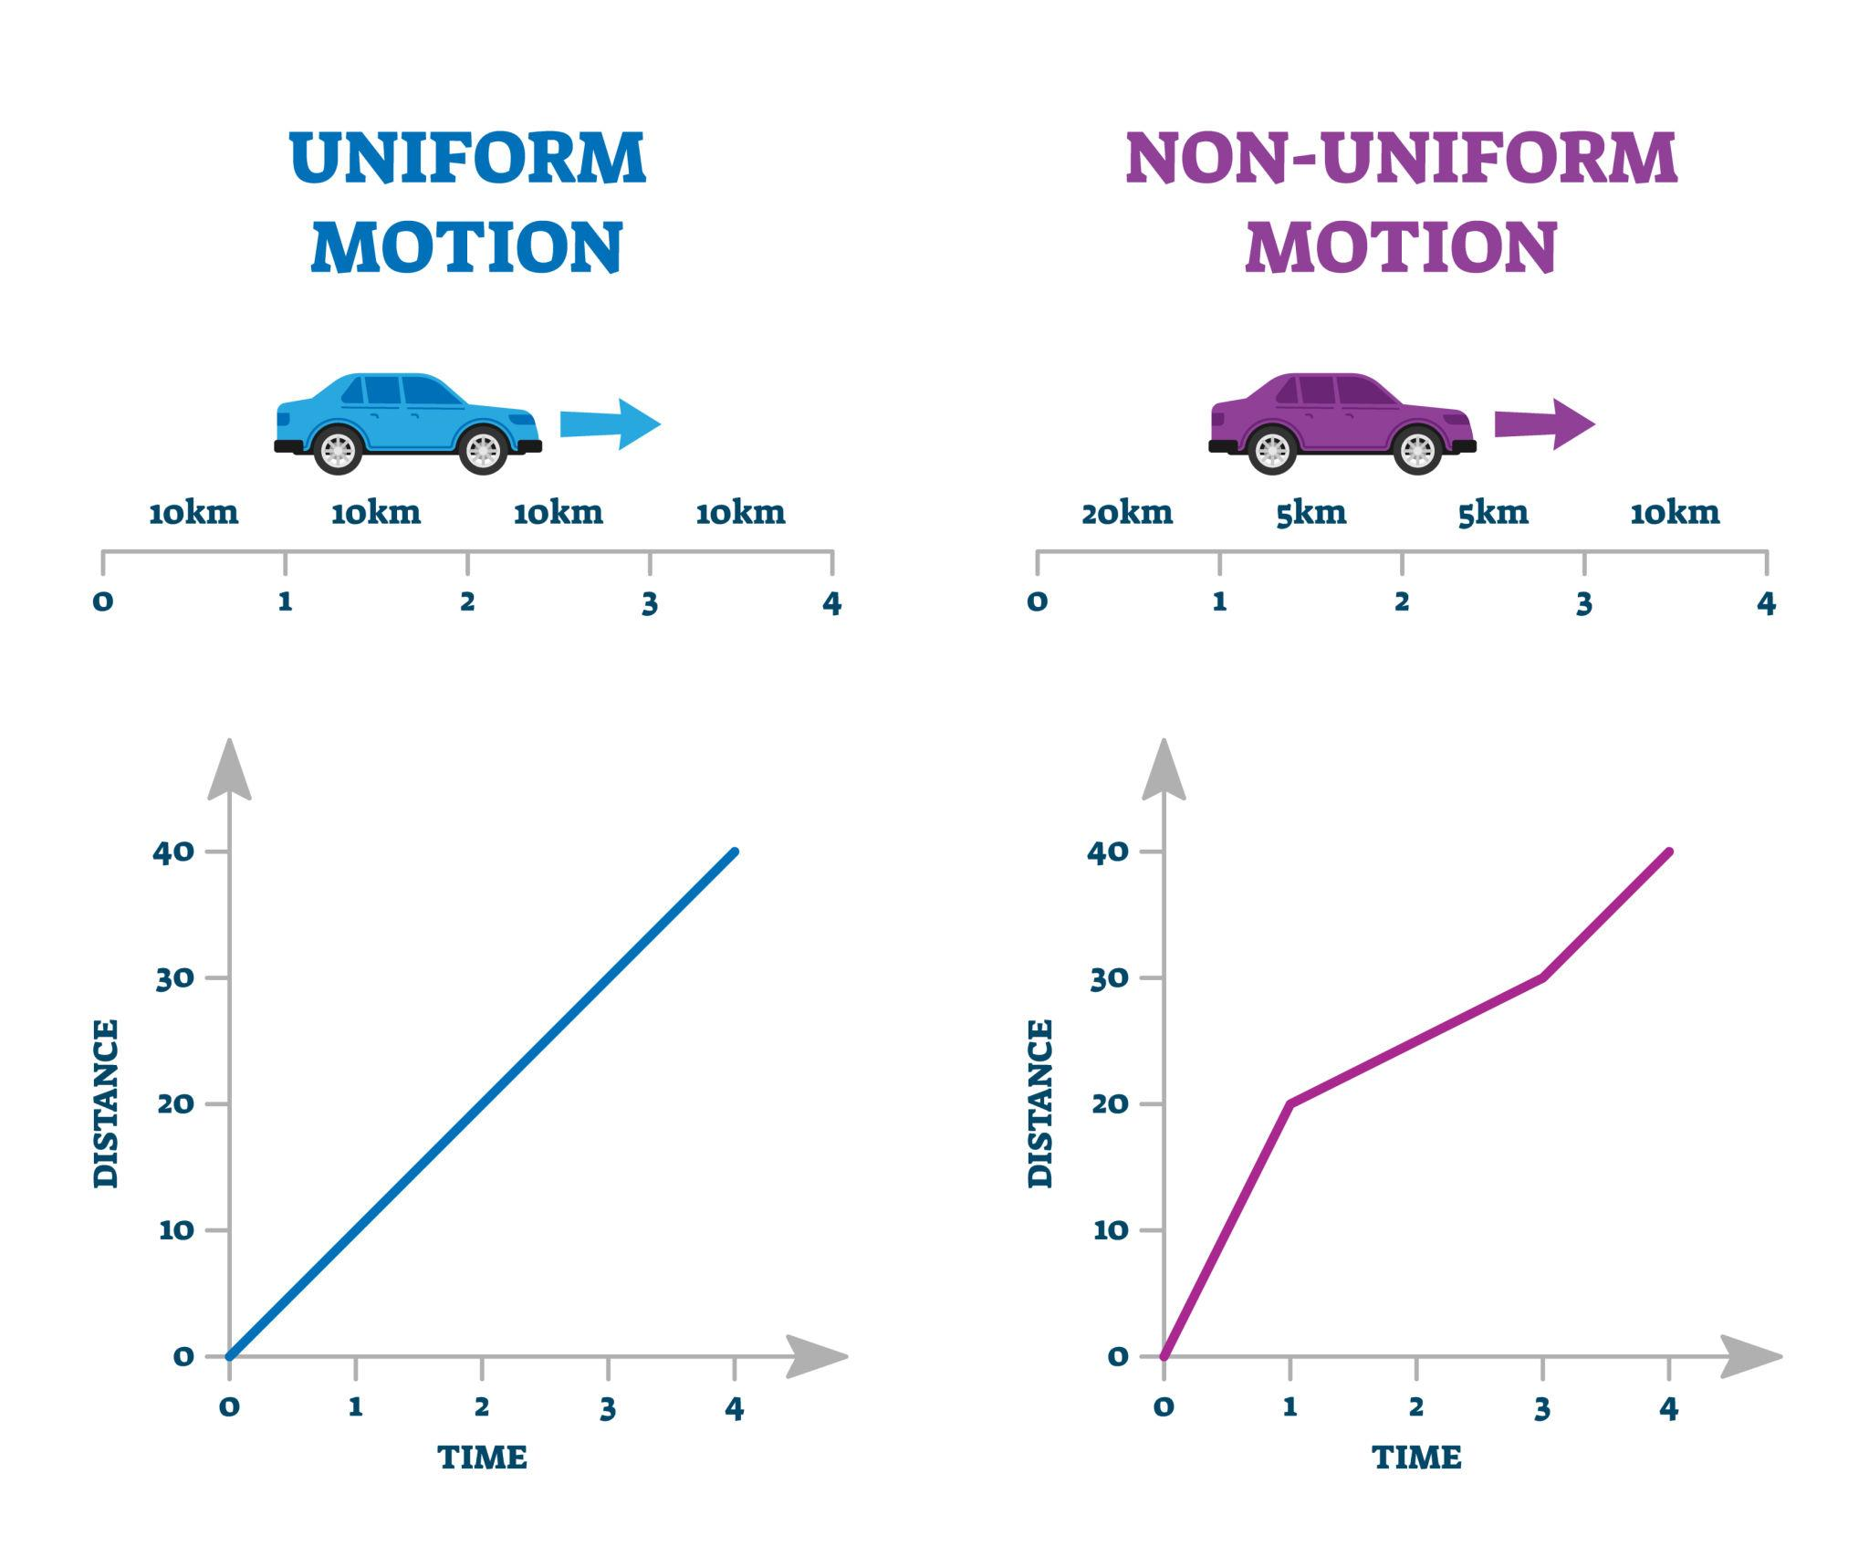
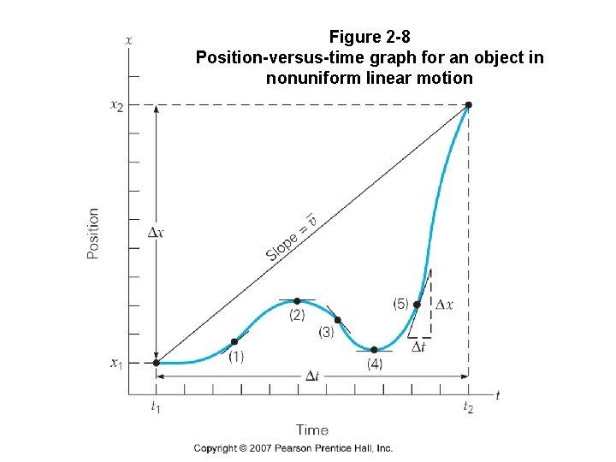
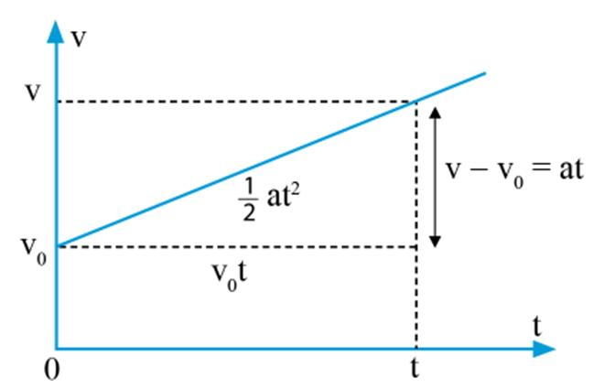
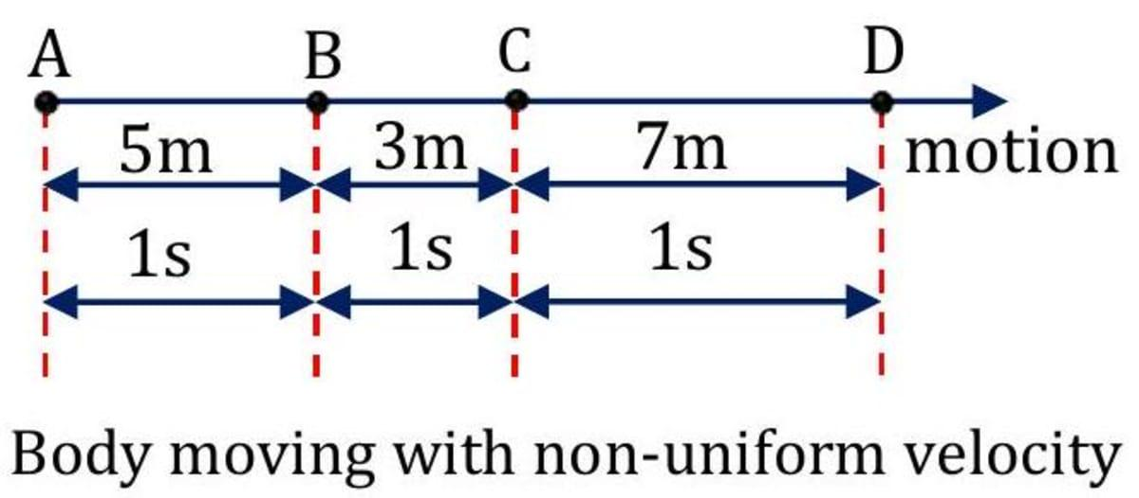
Definition
A Non-Uniform Straight-Line Path is geometrically straight, but the point's speed changes as it moves.
Example
Suppose:
$$x\left(t\right)=t^{2}.$$
Its velocity is:
$$v\left(t\right)=2t.$$
The speed changes with time, but the geometric path remains a straight line.
Important Distinction
$$\boxed{\text{Path geometry}≠\text{speed along the path}}$$
A point can move along the same straight path with either constant or changing speed.

12. Restricted Straight-Line Path
# Source: AI Source: Provided by: [Data Path: Persons Table -> ID Column: 1, Name_En Column: Motasem Essam] -> From: [ChatGPT] on [7/25/2026]
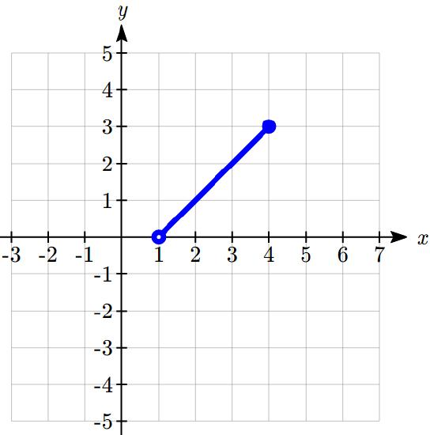
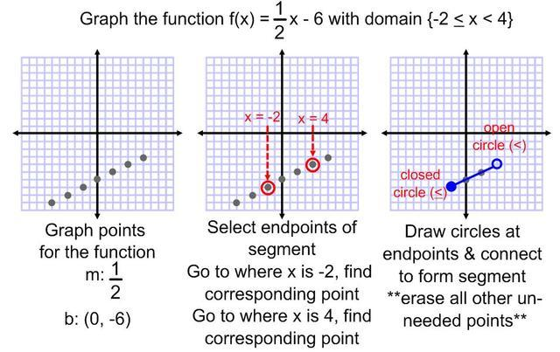
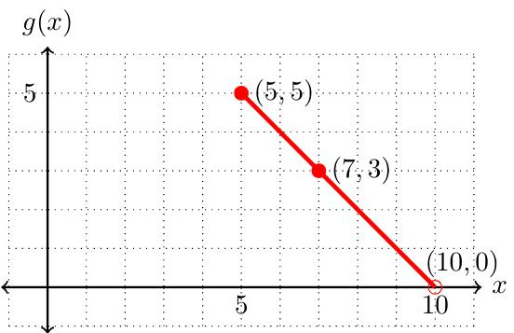
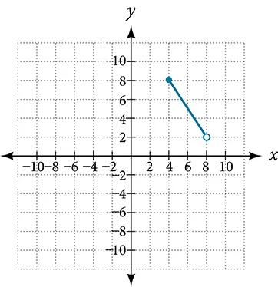
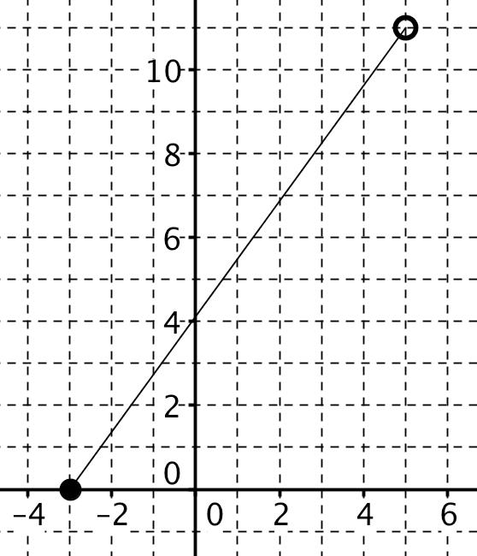
Definition
A Restricted Straight-Line Path is only a specified portion of a straight line.
Example
Consider:
$$y=2x+1$$
with:
$$0≤x≤4.$$
Only the portion between:
$$\left(0 , 1\right)$$
and:
$$\left(4 , 9\right)$$
is allowed.
Therefore, the path is effectively the segment:
$$\boxed{\overset{‾}{\left(0 , 1\right)\left(4 , 9\right)}}.$$

13. Piecewise Straight-Line Path
# Source: AI Source: Provided by: [Data Path: Persons Table -> ID Column: 1, Name_En Column: Motasem Essam] -> From: [ChatGPT] on [7/25/2026]
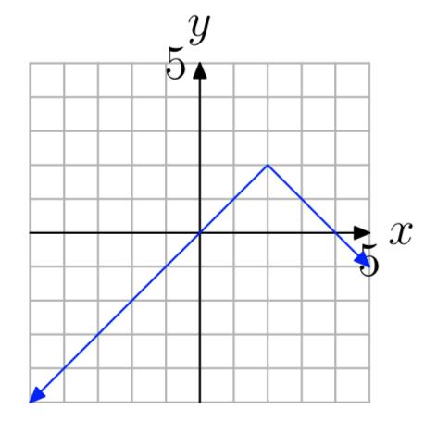
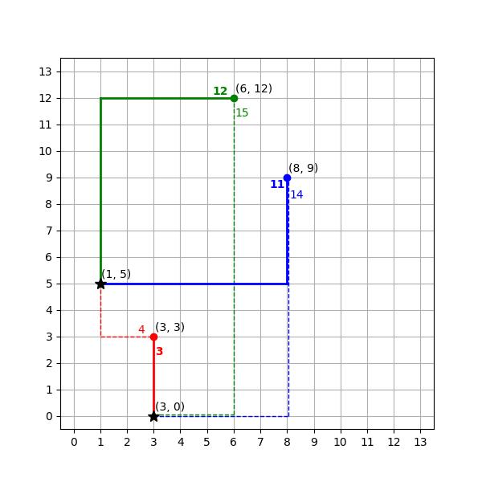
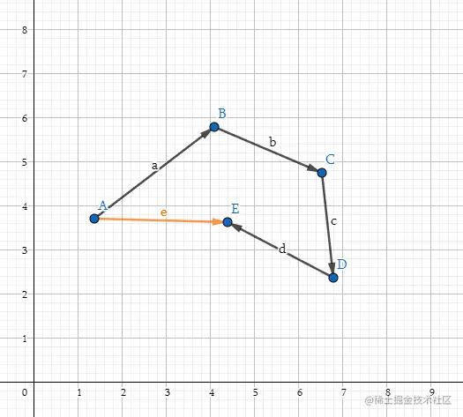
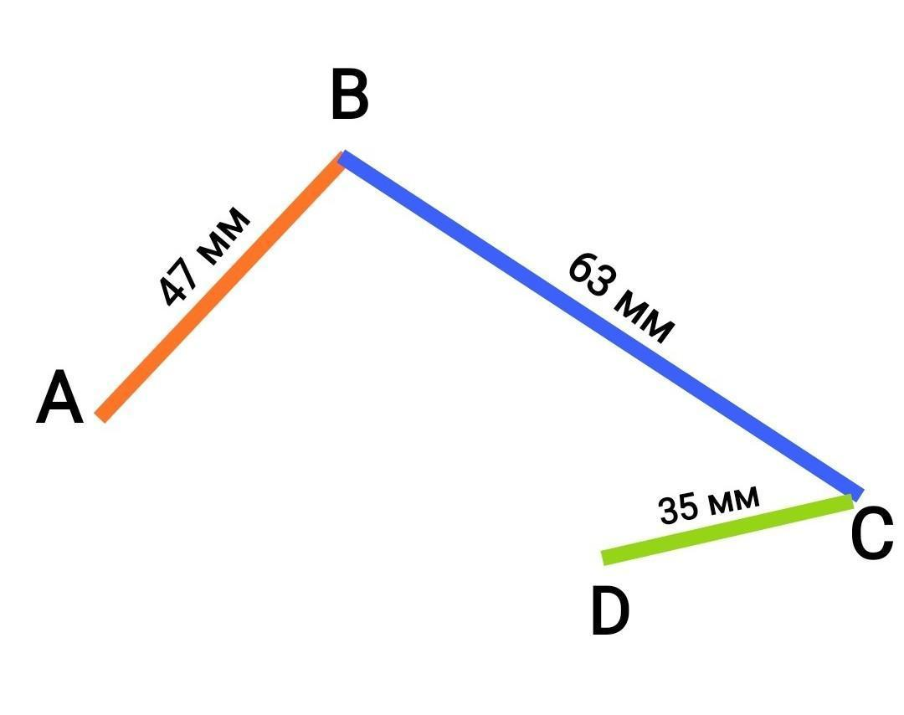
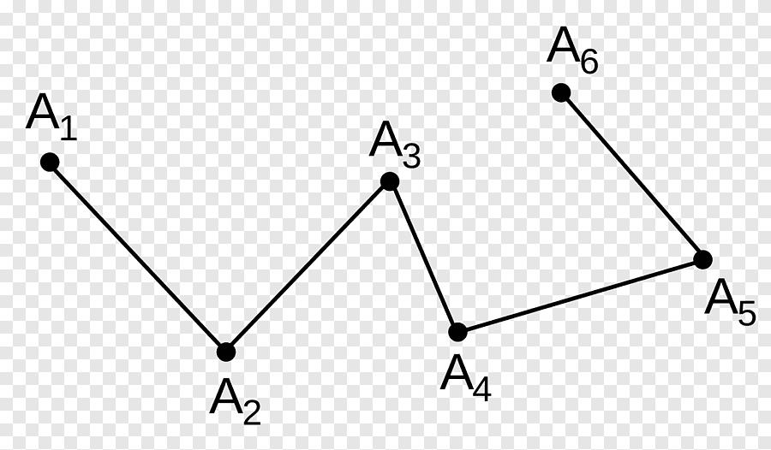
Definition
A Piecewise Straight-Line Path consists of multiple straight segments connected at points.
For example:
$$A→B→C→D.$$
The individual paths are:
$$\overset{‾}{AB}, \overset{‾}{BC}, \overset{‾}{CD}.$$
The direction can change at $B$and $C$.
This is also commonly called a polygonal path or polyline.
Important
Each individual portion is straight, but the entire path is generally not one straight line.

14. Combined Straight-Line Path
# Source: AI Source: Provided by: [Data Path: Persons Table -> ID Column: 1, Name_En Column: Motasem Essam] -> From: [ChatGPT] on [7/25/2026]
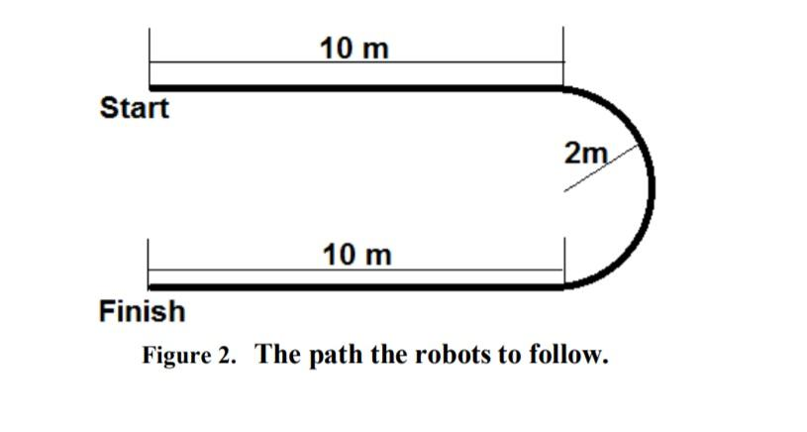
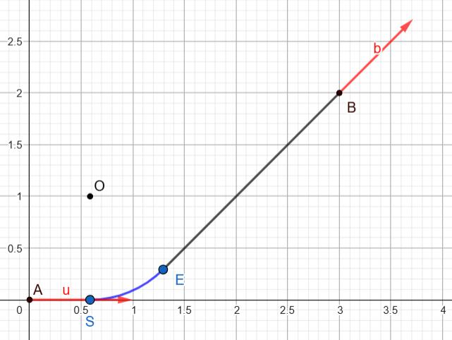
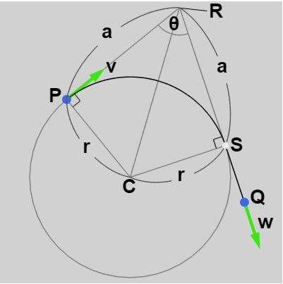
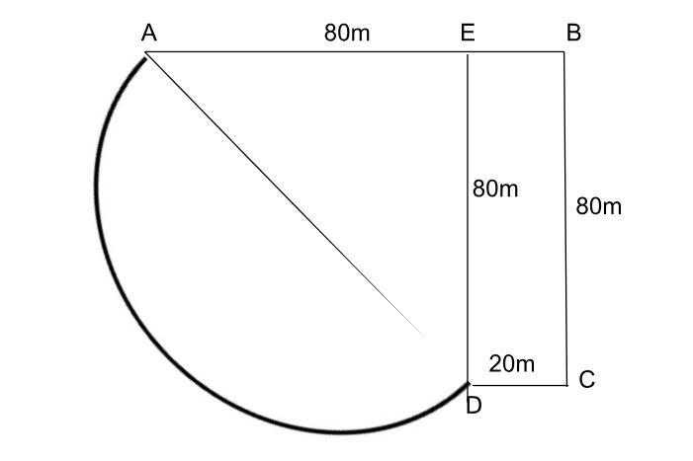
Definition
A Combined Straight-Line Path contains straight-line portions together with other types of geometric paths.
Example
A path could be:
$$A→B$$
along a straight segment, followed by a circular arc:
$$B→C,$$
and then another straight segment:
$$C→D.$$
Thus:
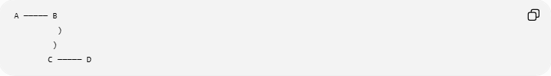
A ───── B
)
)
C ───── D
The complete path is not a single straight-line path.

Straight-Line Path and Direction
# Source: AI Source: Provided by: [Data Path: Persons Table -> ID Column: 1, Name_En Column: Motasem Essam] -> From: [ChatGPT] on [7/25/2026]
A defining property of a straight-line path is constant direction.
A general vector representation is:
$$\boxed{P\left(t\right)=P_{0}+t\vec{v}}$$
where $\vec{v}$is constant.
As $t$changes, the point moves along the same direction.

Straight-Line Path and Curvature
# Source: AI Source: Provided by: [Data Path: Persons Table -> ID Column: 1, Name_En Column: Motasem Essam] -> From: [ChatGPT] on [7/25/2026]
A straight line has zero curvature:
$$\boxed{κ=0}$$
This distinguishes it from curved paths.
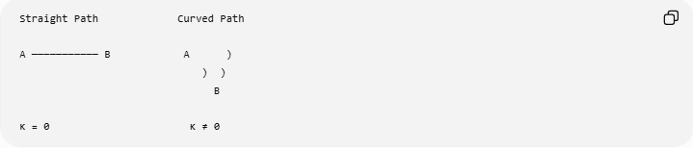
Straight Path Curved Path

A ─────────── B A )
) )
B

κ = 0 κ ≠ 0

Straight-Line Path as the Shortest Path
# Source: AI Source: Provided by: [Data Path: Persons Table -> ID Column: 1, Name_En Column: Motasem Essam] -> From: [ChatGPT] on [7/25/2026]
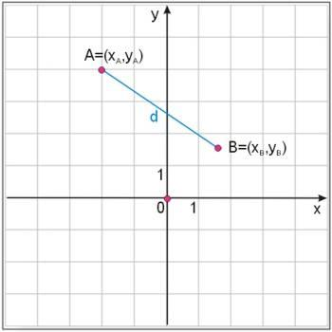
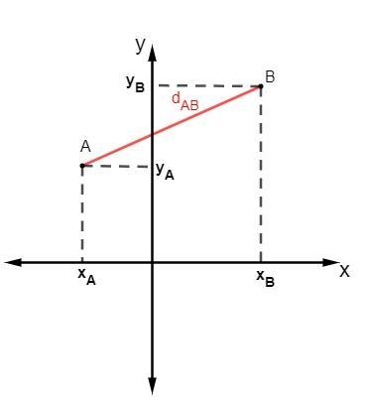
Between two points $A$and $B$, the straight segment is the shortest path.
If another path has length $L$, then:
$$\boxed{L≥AB}$$
Equality occurs when the path is the straight segment:
$$\boxed{L=AB}.$$
Example
If:
$$AB=10,$$
then every other path connecting $A$and $B$has length at least $10$.

Coordinate Distance Along a Straight Path
# Source: AI Source: Provided by: [Data Path: Persons Table -> ID Column: 1, Name_En Column: Motasem Essam] -> From: [ChatGPT] on [7/25/2026]
For:
$$A=\left(x_{1} , y_{1}\right)$$
and:
$$B=\left(x_{2} , y_{2}\right),$$
the length of the straight path between them is:
$$\boxed{AB=\sqrt{{\left(x_{2}-x_{1}\right)}^{2}+{\left(y_{2}-y_{1}\right)}^{2}}}$$
Example
Let:
$$A=\left(1 , 2\right), B=\left(4 , 6\right).$$
Then:
$$AB=\sqrt{{\left(4-1\right)}^{2}+{\left(6-2\right)}^{2}} \\ =\sqrt{9+16} \\ \boxed{AB=5}.$$

Straight-Line Path as a Locus
# Source: AI Source: Provided by: [Data Path: Persons Table -> ID Column: 1, Name_En Column: Motasem Essam] -> From: [ChatGPT] on [7/25/2026]
A straight line can also occur as a locus.
For example:
$$PA=PB$$
defines the perpendicular bisector of $AB$.
Therefore:
$$\boxed{PA=PB→\text{straight-line locus}}$$
The perpendicular bisector is a straight line consisting of all points equidistant from $A$and $B$.

Straight-Line Paths in 3D
# Source: AI Source: Provided by: [Data Path: Persons Table -> ID Column: 1, Name_En Column: Motasem Essam] -> From: [ChatGPT] on [7/25/2026]
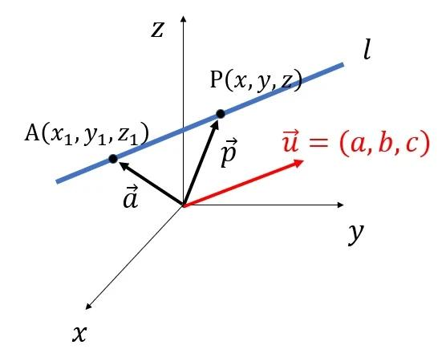
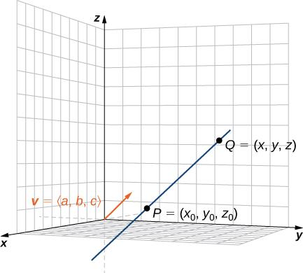
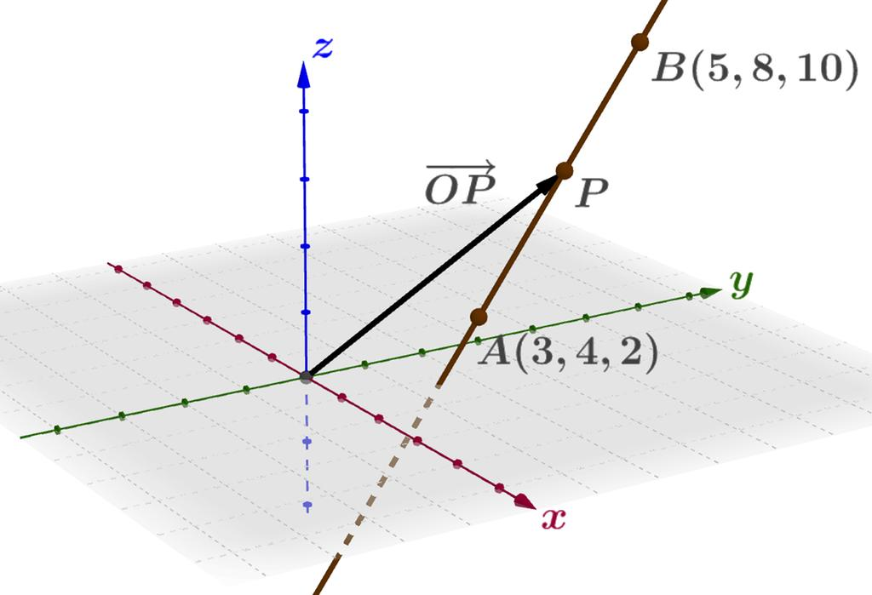
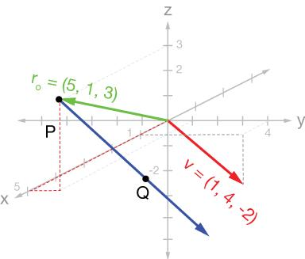
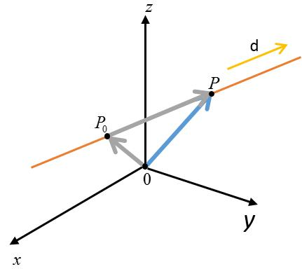
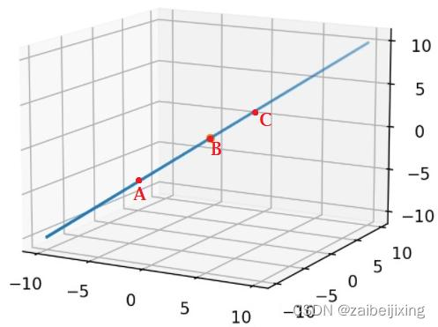
In three-dimensional space, a straight-line path can be represented as:
$$\boxed{\left(x , y , z\right)=\left(x_{0} , y_{0} , z_{0}\right)+t\left(a , b , c\right)}$$
or:
$$\boxed{x=x_{0}+at} \\ \boxed{y=y_{0}+bt} \\ \boxed{z=z_{0}+ct}$$
Example
$$\left(x , y , z\right)=\left(1 , 2 , 3\right)+t\left(2 , - , 14\right)$$
represents a straight path in three-dimensional space.

Straight-Line Path vs Other Geometric Paths
# Source: AI Source: Provided by: [Data Path: Persons Table -> ID Column: 1, Name_En Column: Motasem Essam] -> From: [ChatGPT] on [7/25/2026]
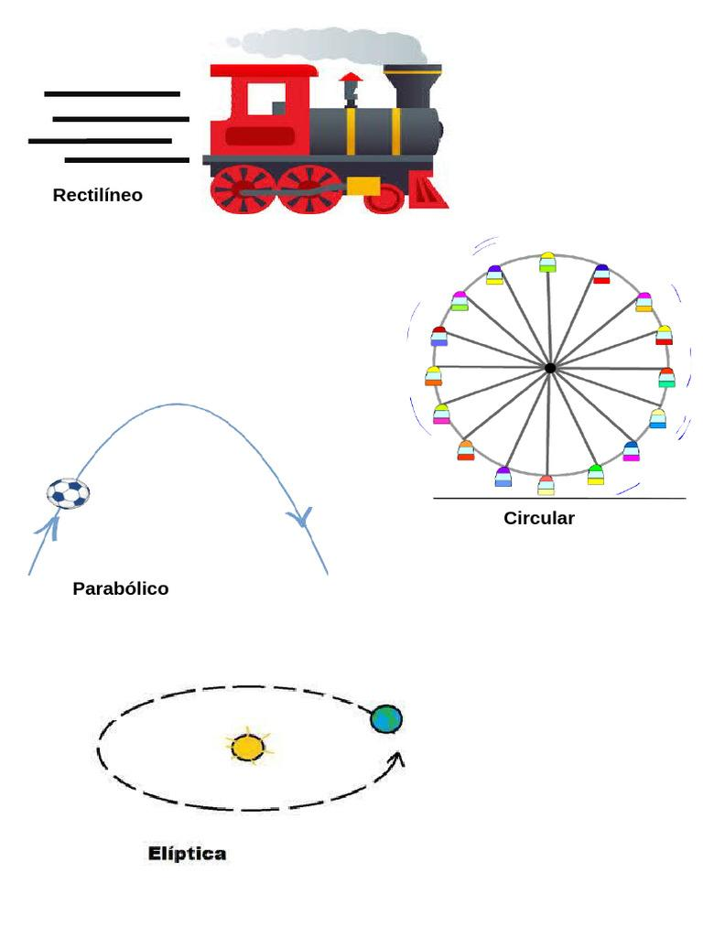
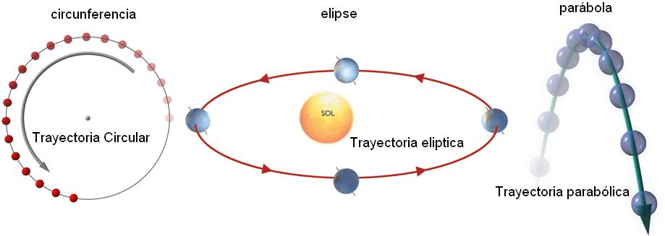
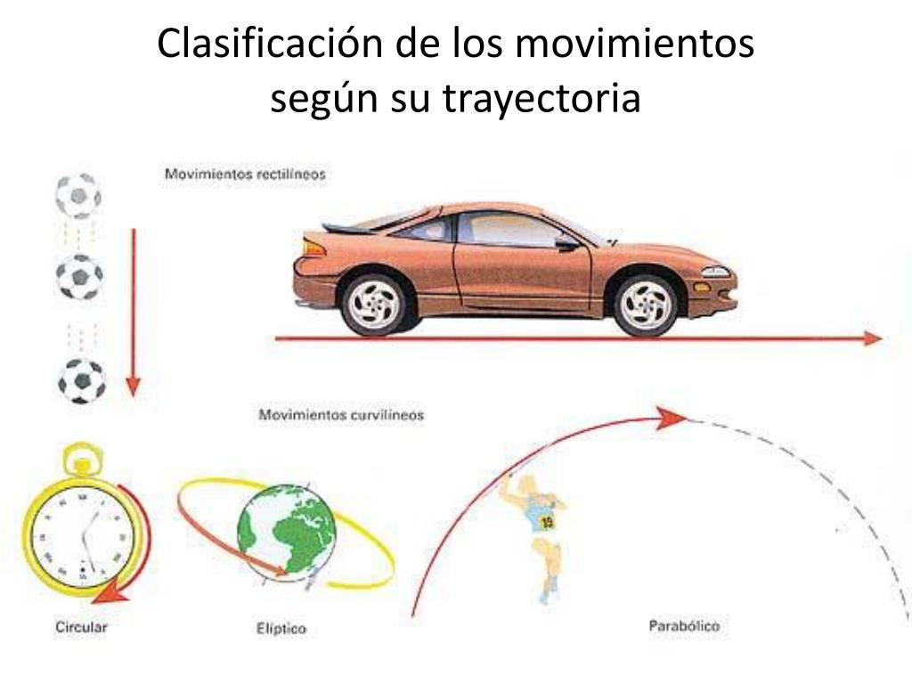
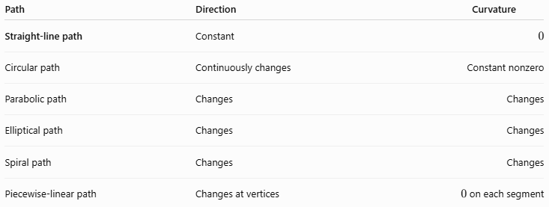
Path | Direction | Curvature
Straight-line path | Constant | $$0$$
Circular path | Continuously changes | Constant nonzero
Parabolic path | Changes | Changes
Elliptical path | Changes | Changes
Spiral path | Changes | Changes
Piecewise-linear path | Changes at vertices | $0$on each segment

Line, Ray, and Segment
# Source: AI Source: Provided by: [Data Path: Persons Table -> ID Column: 1, Name_En Column: Motasem Essam] -> From: [ChatGPT] on [7/25/2026]
These three are the fundamental forms of a straight geometric path.
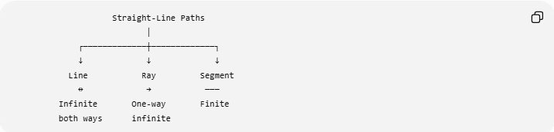
Straight-Line Paths
│
┌─────────────┼─────────────┐
↓ ↓ ↓
Line Ray Segment
↔ → ───
Infinite One-way Finite
both ways infinite
Line
$$\boxed{\overset{↔}{AB}}$$
Infinite in both directions.
Ray
$$\boxed{\vec{AB}}$$
One endpoint and infinite in one direction.
Segment
$$\boxed{\overset{‾}{AB}}$$
Two endpoints and finite length.

Key Properties
# Source: AI Source: Provided by: [Data Path: Persons Table -> ID Column: 1, Name_En Column: Motasem Essam] -> From: [ChatGPT] on [7/25/2026]
1. Constant Direction
$$\boxed{\vec{v}=\text{constant}}$$
2. Zero Curvature
$$\boxed{κ=0}$$
3. No Turning
The direction remains unchanged.
4. Shortest Path
$$\boxed{AB≤L}$$
for any path of length $L$connecting $A$and $B$.
5. Constant Slope
For a nonvertical straight line:
$$\boxed{m=\text{constant}}$$
6. Collinearity
All points on a single straight-line path are collinear.
For points $A,B,C$:
$$\boxed{A,B,C\text{ are collinear}}$$
if they all lie on the same straight line.

Classification Summary
# Source: AI Source: Provided by: [Data Path: Persons Table -> ID Column: 1, Name_En Column: Motasem Essam] -> From: [ChatGPT] on [7/25/2026]
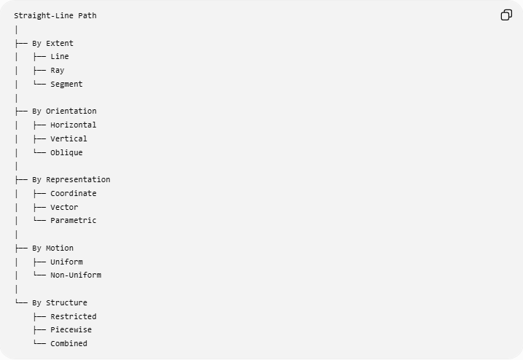
Straight-Line Path
│
├── By Extent
│ ├── Line
│ ├── Ray
│ └── Segment
│
├── By Orientation
│ ├── Horizontal
│ ├── Vertical
│ └── Oblique
│
├── By Representation
│ ├── Coordinate
│ ├── Vector
│ └── Parametric
│
├── By Motion
│ ├── Uniform
│ └── Non-Uniform
│
└── By Structure
├── Restricted
├── Piecewise
└── Combined

Key Formulas
# Source: AI Source: Provided by: [Data Path: Persons Table -> ID Column: 1, Name_En Column: Motasem Essam] -> From: [ChatGPT] on [7/25/2026]
General Cartesian Form
$$\boxed{ax+by+c=0}$$
Slope-Intercept Form
$$\boxed{y=mx+b}$$
Slope
$$\boxed{m=\frac{y_{2}-y_{1}}{x_{2}-x_{1}}}$$
Distance Between Two Points
$$\boxed{AB=\sqrt{{\left(x_{2}-x_{1}\right)}^{2}+{\left(y_{2}-y_{1}\right)}^{2}}}$$
Vector Form
$$\boxed{\vec{r}={\vec{r}}_{0}+t\vec{v}}$$
Parametric Form
$$\boxed{x=x_{0}+at, y=y_{0}+bt}$$
3D Parametric Form
$$\boxed{x=x_{0}+at, y=y_{0}+bt, z=z_{0}+ct}$$
Curvature
$$\boxed{κ=0}$$
Shortest-Path Property
$$\boxed{L≥AB}$$
with equality for the straight segment.

Key Points
# Source: AI Source: Provided by: [Data Path: Persons Table -> ID Column: 1, Name_En Column: Motasem Essam] -> From: [ChatGPT] on [7/25/2026]
- A Straight-Line Path is a path with constant direction.
- It has zero curvature:
$$κ=0.$$
- Its three fundamental forms are line, ray, and segment.
- A straight path can be horizontal, vertical, or oblique.
- It can be represented using Cartesian, vector, or parametric equations.
- The speed along the path may be constant or variable without changing the geometric path.
- The straight segment between two points is their shortest path.
- A collection of connected straight segments forms a piecewise-linear path.
- Straight-line paths are fundamental in coordinate geometry, vector geometry, loci, constructions, distance problems, and motion.

Conclusion
# Source: AI Source: Provided by: [Data Path: Persons Table -> ID Column: 1, Name_En Column: Motasem Essam] -> From: [ChatGPT] on [7/25/2026]
A Straight-Line Path is the fundamental geometric path characterized by constant direction and zero curvature. Its principal forms are:
$$\boxed{\text{Line}, \text{Ray}, \text{Segment}}$$
and it can be described using equations such as:
$$\boxed{ax+by+c=0}$$
or:
$$\boxed{\vec{r}={\vec{r}}_{0}+t\vec{v}}.$$
The straight-line path is especially important because it represents the shortest path between two points and provides the basic building block for more complex paths such as polygonal and piecewise-linear paths.

